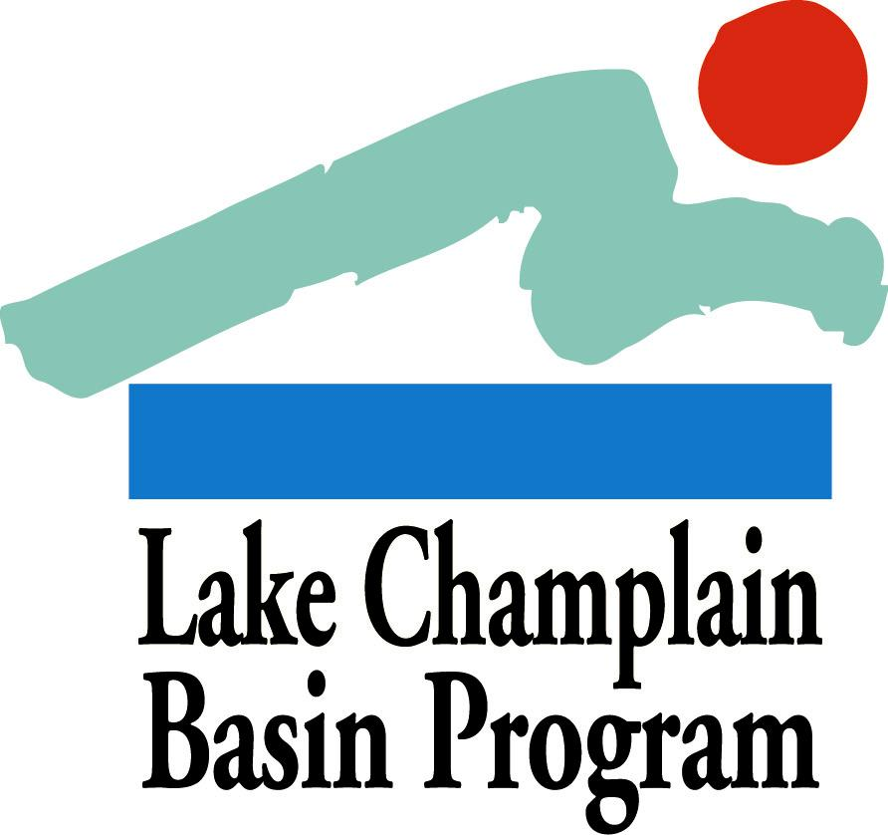

2013 Organizational Support Grants:

APPLICATION FORM

Applications must use the format below and provide all of the information requested to be considered for review.

Summary Page
On a single page, please provide the following information in the order shown:

Project Name/Title:

Project Category: Organizational Support

Contact Information:

Name of Contact Person:
Authorized Signatory and Title (if different from Contact Person):
Organization:
Mailing Address:
Phone and FAX numbers:
Electronic Mail Address:

Eligibility: Please list all of your organization’s current Lake Champlain Basin Program grants. Any organization with an existing award that has overdue workplans, reports, or other deliverables is ineligible and should not apply.

All new projects will be required to submit a workplan within sixty days after award notifications are made. Projects must be initiated no more than six months after award notification. If these deadline specifications are not met then awards will be lost.

Amount of LCBP Request:

Organization Mission Statement: (3-5 sentences)

Brief Summary: Please describe your request in 3-5 sentences

Outcome/Deliverable: Please provide one sentence describing measurable project outcomes.

Application Questions
Please answer the following questions in order, using no more that 3 pages combined (12 point Times New Roman (or equivalent) font or larger, minimum 1 inch margin on all sides). Complete applications should be no longer than 5 pages in length (1 summary page, 3 pages for application questions/answers, 1 budget page). Additional pages, with the exception of letters of support (3 maximum) will NOT be reviewed.

Please include both the questions and your answers in the narrative, which should describe your request as directly and concisely as possible. The review committee will evaluate your application based on your answers to these questions, according to the criteria listed in the Grant Guidelines.

- Please provide a brief description of your organization and its history to date. Include your organization’s mission statement, organizational structure, number of members if it is a membership organization, and attach the resume of the organization’s director/coordinator.
- Describe what the funds will be used for and how this will strengthen your organization. What benchmarks will you use to evaluate success? What tangible products or measurable results will be produced?

C. Budget Table and Justification
Please use the format below for your budget table.
- If the LCBP request is part of a larger project, please indicate the estimated total project value and the funding source(s) for the entire project.
- All expenses should be placed into one of the following major categories:
  - Direct Costs - subcategories include: Personnel (including fringe benefits), Supplies, Contracts, Equipment, and Travel.
  - Indirect Costs – include general office and operating expenses, insurance, bookkeeping, etc. Please refer to the Grant Guidelines for more information about direct and indirect costs, eligible expenses, and matching contributions. Please note that LCBP’s policy for indirect project costs is a maximum of 21% of the total project budget.
- If your project includes several tasks, it is helpful for each task’s budget to be broken out separately from the other tasks.
- List additional specific expense categories where appropriate as indicated.
- Budget items should be divided into funding sources as shown in the budget table. At minimum, show which items will be covered by the LCBP grant and which items will be part of your matching contribution (if matching contributions will be used). List other sources of funding that are not being used as match (such as other federal funds) following your budget table, as shown.
- In addition to the budget table, please include a brief justification for each line in your budget, as in the following example:
- Project Coordinator: supports staffing for oversight of project activities, 50 hours @ $18/hr.
Budget Table Format (Dollar values for illustration only.)

Expense | LCBP Grant Request | Non-Federal  Matching Contribution | Totals
DIRECT Costs:
Personnel
Project Coordinator | $900 | $100 | $1000
Volunteers |  | $250 | $250
(Add specific lines as needed)
Travel | $100 | $100 | $200
(Add specific lines as needed)
Supplies/Materials
Printing | $250 |  | $250
Mailing | $75 |  | $75
(Add specific lines as needed)
Contracts
(Add specific lines as needed)
Equipment
(Add specific lines as needed)
Other (please specify)
INDIRECT Costs: | $100 | $100 | $200
Totals | $1,425 | $550 | $1,975
*Additional federal funds supporting this project include $500 from an EPA grant.

D. Letters of Support
Attach any required letters of participation and up to three letters of support to your application. Please be sure that the letters are signed by the appropriate authors. Letters of support received separately from the application will not be included in the application review. See the Grant Guidelines for more information.

E. Submission Process
- Please submit ten (10) hardcopies of each application to the LCBP address listed below. In addition, please submit the electronic versions of your summary page, application questions, and budget page either on compact disk or by email to grants@lcbp.org.
- Both hardcopies and electronic versions must be submitted by the due date.

Applications must be received in the Basin Program Office by 4:30 PM, Thursday, Nov. 14, 2013.
Successful applicants will be notified by early January, 2014. Send completed applications (hard copy and electronic version) to grants@lcbp.org. Direct all questions to Kathy Jarvis, Office Manager (kjarvis@lcbp.org).

PHONE: 800-468-5227 (Toll free in VT/NY) or 802-372-3213

ADDRESS: Lake Champlain Basin Program, 54 West Shore Road, Grand Isle, VT 05458

