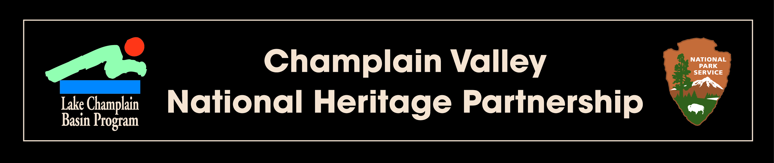

2014 Local Heritage Grant

Project Workplan

Project Title:

Point Of Contact and Authorized Representative (include name, address, phone and e-mail)

Project Location (County): (county, or counties where project takes place)

Project Location (Lake Champlain Watershed): (if applicable)

GPS Coordinates: (project site or organization’s headquarters location)

Project Summary: (use summary from grant application)

OFA Action /Task ID (examples, please use the actions and tasks included in your grant application)
The project supports the following action(s) and task(s) of the Cultural Heritage and Recreation chapter of Opportunities for Action: (examples below: use actions/tasks identified in application)
Action 9.6: Support initiatives that promote sustainable recreational activities that feature the natural, cultural, and historical resources in the CVNHP.
Task 9.6.1: Develop and/or improve natural and cultural heritage interpretative trails using wayside exhibits and other informative media.
Task 9.6.2: Continue to support regional, multi-jurisdictional programs that promote accessible and sustainable use of resources.
Task 9.6.5: Support efforts to link communities through transportation routes that feature interpretation of heritage resources.
Action 9.10: Support the use of interpretive themes to link resources within the CVNHP.
Task 9.10.4: Support initiatives that highlight the relationships among stakeholder sites and programs through interpretation, while maintaining the individual character of those sites.
Project Outline
Task | Task Title | Objective | Deliverable | Date
1
2
3
4

Project Schedule

Project Start: (date)

Project Completion: (date)

Project Budget
(Include budget from grant application.)

Project Deliverables:

Press release announcing grant award and describing project.

Digital copies of (or electronic links to) any media coverage of the project.

Three digital photos (at least 300 dpi) of people participating in activities relating to the grant

(In addition to the required items above, include deliverables from grant application.)

Note: The LCBP requires acknowledgement that "Funding for this project came from an Education and Outreach grant from the Champlain Valley National Heritage Partnership" on new printed and visual materials generated by this project. Prior to publication, all printed and electronic promotional or interpretive materials should be reviewed by the LCBP/CVNHP contract officer. This requirement reflects the LCBP’s obligations to federal funding agencies that restrict advocacy, fundraising and require accuracy in interpretive materials produced. Contractors should provide at least 21 days for contract officer review of draft material.

Proper Submittal of Deliverables: All final report materials must be submitted on a CD, or on a USB “flash drive.” Reporting materials should be submitted in Microsoft (Word, Publisher, Excel, etc.), or in a comparable format. Original reports formatted as a PDF will not be accepted; however scanned images of news clippings, brochures, and other project materials may be submitted as PDF documents. Submission of these materials implies unrestricted use by the CVNHP, the National Park Service and the Lake Champlain Basin Program.

