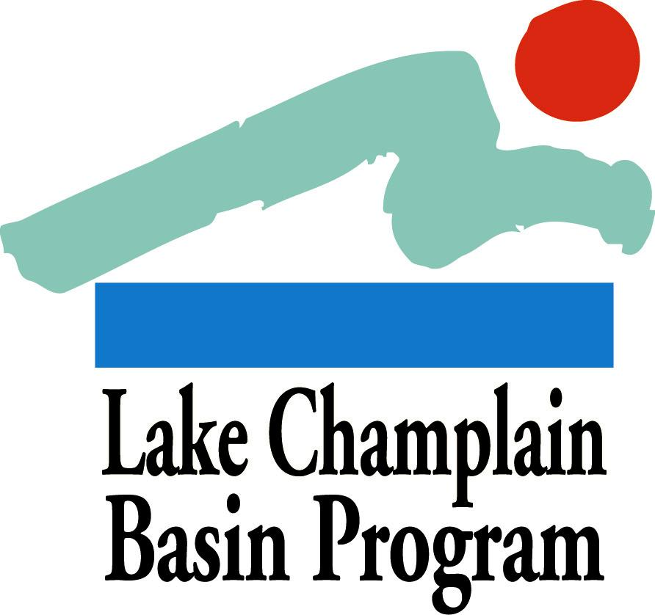

2014 Organizational Support Grants:

APPLICATION FORM

Applications must use the format below and provide all of the information requested to be considered for review.

Summary Page
On a single page, please provide the following information in the order shown:

Project Name/Title:

Project Category: Organizational Support

Contact Information:

Name of Contact Person:
Authorized Signatory and Title (if different from Contact Person):
Organization:
Mailing Address:
Phone and FAX numbers:
Electronic Mail Address:

Eligibility: Please list all of your organization’s current Lake Champlain Basin Program grants. Any organization with an existing award that has overdue workplans, reports, or other deliverables is ineligible and should not apply.

All new projects will be required to submit a workplan within sixty days after award notifications are made. Projects must be initiated no more than six months after award notification. If these deadline specifications are not met then awards will be lost.

Amount of LCBP Request:

Organization Mission Statement: (3-5 sentences)

Brief Summary: Please describe your request in 3-5 sentences

Outcome/Deliverable: Please provide one sentence describing measurable project outcomes.

Application Questions
Please answer the following questions in order, using no more that 3 pages combined (12 point Times New Roman (or equivalent) font or larger, minimum 1 inch margin on all sides). Complete applications should be no longer than 5 pages in length (1 summary page, 3 pages for application questions/answers, 1 budget page). Additional pages, with the exception of letters of support (3 maximum) will NOT be reviewed.

Please include both the questions and your answers in the narrative, which should describe your request as directly and concisely as possible. The review committee will evaluate your application based on your answers to these questions, according to the criteria listed in the Grant Guidelines.

- Please provide a brief description of your organization and its history to date. Include your organization’s mission statement, organizational structure, number of members if it is a membership organization, and attach the resume of the organization’s director/coordinator.
- Describe what the funds will be used for and how this will strengthen your organization. What benchmarks will you use to evaluate success? What tangible products or measurable results will be produced?
- Project Objective, Task, Deliverable and Timeline Table Format – EXAMPLE ONLY (please fill in for your application)

Task # | Objective | Task Title | Deliverable | Timeline
1 | Engage public | Hold public forum | Press release | March, 2014
2 | Education outreach | Contact watershed teachers about use of model, newsletter development and distribution | Contact letter, spring 2014 newsletter | March-May, 2014
3 | River clean up | Organize and hold river clean up | Press release, photos | June-August, 2014
4 | Complete final report |  | Final report, fall 2014 newsletter | December, 2014

C. Budget Table and Justification
Please use the format below for your budget table.
- If the LCBP request is part of a larger project, please indicate the estimated total project value and the funding source.
- All expenses should be placed into one of the following major categories:
  - Direct Costs - subcategories include: Personnel, Fringe Benefits, Travel, Supplies, Professional Services.
  - Indirect Costs – include general office and operating expenses, insurance, bookkeeping, etc. Please refer to the Grant Guidelines for more information about direct and indirect costs.
- List additional specific expense categories where appropriate.
- Budget items should be divided into funding sources as shown in the budget table. At minimum, show which items will be covered by the LCBP grant and which items will be part of your matching contribution (if matching contributions will be used). List other sources of funding that are not being used as match (such as other federal funds) below your budget table, as shown.
- In addition to the budget table, please include a brief justification for each line in each task in your budget, as in the following example:
- Personnel: Staffing for project planning (Task 1) supports staffing for oversight of project activities, 50 hours @ $18/hr. Proposed match includes staff time and volunteer time for all tasks.
- Fringe: Fringe refers to benefits and is calculated as an appropriate percentage of personnel costs for each Tasks. Proposed Match can include unrecovered costs to applicant not included in this grant request.
- Supplies: Examples are photocopying & mailing (Task 1). Match includes the value of donated materials.
- Professional Services: Example would be hiring a subcontractor to complete a specific task.
- Indirect: Indirect includes real expenses that are part of the cost of doing this business, but not directly expended on tasks. Examples include paying an auditor at the end of the year, insuring the office, or other expenses that are not directly supporting these tasks, but are necessary expenses in order to handle this work. Indirect is calculated at an appropriate percent of direct costs for all tasks (the example of 12.5% used here may be higher or lower than your indirect).

Budget Table Format (Dollar values for illustration only.)

Project Budget: Line Item by Task
Line Item | Task 1 | Task X (add or remove columns as needed) | Line Item Totals for All Tasks | Proposed Match (if any) | Line Item Totals + Proposed Match
Personnel | $900 | - | $900 | $350 | $1,250
Fringe | $270 | - | $270 | $0 | $270
Travel | $100 | - | $100 | $100 | $200
Supplies | $325 | - | $325 | $0 | $325
Professional Services | $0 | - | $0 | $0 | $0
Total Direct | $1,595 | - | $1,595 | $450 | $2,045
Indirect | $199 | - | $199 | $100 | $299
TOTAL BUDGET | $1,794 | - | $1,794 | $550 | $2,344

*Additional federal funds supporting this project include $500 from an EPA grant.
A budget template is available in MS Excel: http://www.lcbp.org/wp-content/uploads/2014/09/LCBP-Local-Grants-budget-calculator.xlsx.

D. Letters of Support
Attach any required letters of participation and up to three letters of support to your application. Please be sure that the letters are signed by the appropriate authors. Letters of support received separately from the application will not be included in the application review. See the Grant Guidelines for more information.

E. Submission Process
- Submit an Electronic version of your application to grants@lcbp.org no later than 4:30 PM Wednesday, November 5, 2014. Electronic submission to grants@lcbp.org is required. Please be sure you receive email notification that your application was received. Electronic submissions must be in MS Word or Word-compatible format.
- NEW in 2014: Hardcopies will NOT be accepted.

Applications must be received in the Basin Program Office by
4:30 PM Wednesday November 5th, 2014.

Successful applicants will be notified as early as December 31, 2014.

Send completed applications (electronic versions only will be accepted) to grants@lcbp.org. Direct all questions to Kathy Jarvis, Office Manager (kjarvis@lcbp.org).

PHONE: 800-468-5227 (Toll free in VT/NY) or 802-372-3213

ADDRESS: Lake Champlain Basin Program, 54 West Shore Road, Grand Isle, VT 05458

