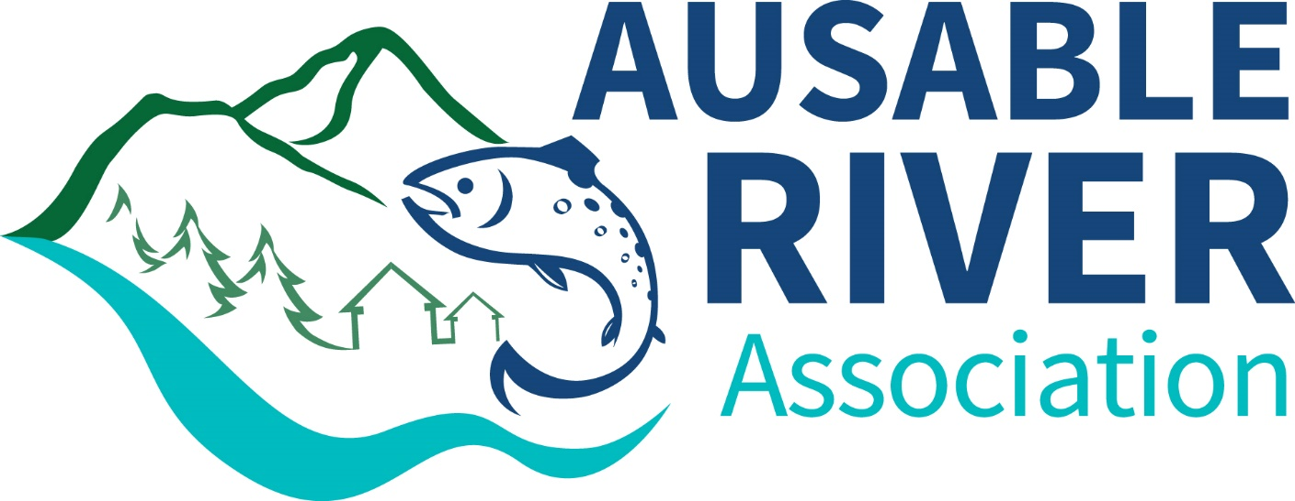  

**Final Report**

**NEIWPCC Job Code: 0100-310-027**

**Project Code: L-2016-001**

**Prepared By: Nicole Pionteck – Ausable River Association**

**Date Submitted: December 2016**

**Date Approved:**

**2016 Aquatic Invasive Species River Steward**

**Contact Information**

Kelley Tucker, Executive Director

Ausable River Association

1181 Haselton Rd, PO Box 8, Wilmington, NY 12997

518.637.6859, ktucker@ausableriver.org

This is a Lake Champlain Basin Program funded project

54 West Shore Rd

Grand Isle, VT 05482

802.372.3213

www.lcbp.org

This project was selected for funding by the Lake Champlain Basin Program (LCBP) Steering Committee and it has been supported directly by an agreement or sub-award issued by the New England Interstate Water Pollution Control Commission (NEIWPCC). NEIWPCC manages LCBP’s personnel, contracts, grants, and budget tasks through a partnership with the LCBP Steering Committee.

Although the information in this document may have been funded wholly or in part by the United States Environmental Protection Agency (under agreement CE982720010), the National Park Service, or by the International Great Lakes Fishery Commission, through their respective contracts to NEIWPCC, it has not undergone review by the Agency, Service, or Commission, and no official endorsement of the content of the document should be inferred. The viewpoints expressed here do not necessarily represent those of NEIWPCC, the LCBP, the USEPA, the NPS, or the GLFC, nor does mention of trade names, commercial products, or causes constitute endorsement or recommendation for use.

**Table of Contents**

**Executive Summary4**

**Introduction5**

**Methods6**

**Results8**

River Users9

Footwear Choice10

Cleaning Methods11

Invasive Species Infestations12

Bait Shop Survey12

Additional Outreach13

**Discussion13**

**Conclusions and Recommendations15**

**Appendices16**

**Executive Summary**

The Ausable River is the longest of three Adirondack rivers that flows into Lake Champlain and has the potential to be a major vector for aquatic invasive species (AIS) spread. The Ausable River is known for its spectacular vistas and world class trout fishery and cannot afford the ecosystem-changing invasions of AIS whether it is a nuisance invader like didymo, or non-native invasives like New Zealand mud snail, rusty crayfish, or fish disease. The Ausable River Association’s River Steward Program works to protect the Ausable River and associated lakes from aquatic invasive species, and in doing so helps to protect the Lake Champlain Basin.

The River Steward program began in 2010 and has been successfully disseminating the AIS spread prevention message and collecting survey data for six years. The goal of the program is to educate the public through multiple outlets such as direct streamside education to river users, distributing spread prevention materials to local businesses, and educating at public events. In addition to providing AIS spread prevention education, the river steward maintains wader wash stations, providing an on-site way for anglers to keep AIS out of the river, and observes and reports new terrestrial or aquatic invasive infestations in the watershed.

In 2016, the river steward was active from May 20 through October 10 and was an on-the-river resource during peak fishing times, early morning and early evening. The steward’s main objective was to provide spread prevention education to river users and administer a survey to gather data. The survey administered gathered information on previous bodies of water visited, type of gear used, and gear cleaning methods. This data is used to determine AIS threats to the Ausable River and its watershed and to refine education and outreach methods.

Over the program’s six years, results from the data have confirmed that awareness and action are integral to early identification and spread limitation of invasive species. Anglers and river users are becoming more aware of the threat of AIS and making important choices such as choosing non-felt boots and using wader wash stations to prevent invasives from entering the Ausable River. The river continues to be free from the nuisance species didymo and remains a healthy trout fishery for recreational users.

**Introduction**

Aquatic invasive species (AIS) that disturb river systems are quickly making their way into the Lake Champlain Basin. The Ausable River, though currently healthy, is stressed, and cannot afford to be affected by nuisance species or invaders. AIS such as New Zealand mud snail, rusty crayfish, and fish diseases, and nuisance species such as didymo threaten both the Ausable River’s ecosystems and the region’s tourism. The introduction of these invasive or nuisance species, combined with already established terrestrial invasive species, could have a devastating impact on the river. AIS affect water quality, habitat diversity, and nutrient processing, putting stress on already threatened native species such as brook trout. The Ausable River brings about $3.8 million to the region annually through its world class trout fishing tourism, supporting local fly shops, fishing guides, and other businesses. The Ausable’s beautiful scenery also attracts paddlers and hikers to the area. To help protect the Ausable River from AIS, the Ausable River Association’s (AsRA) River Steward program performs education and outreach to river users and conducts monitoring aimed at early detection, creating awareness and helping to prevent the spread of invasive species.

In 2015, with funding from NEIWPCC awarded through LCBP, the Ausable River Association (AsRA) hired, trained, and deployed its current AIS river steward on the Ausable River in New York State’s central Champlain region. This highly successful program was previously implemented during the summers of 2010-12, 2014, and 2015 and has continued to be an important resource on the river through 2016. The River Steward program works to protect the Ausable River, and the many lakes within its watershed, from aquatic invasive species through spread prevention. Spread prevention relies on public education, early detection of species, and rapid response to new threats. The river steward traveled throughout the Ausable region, delivering the “Check, Clean, Dry” message to river users, the general public, visitor bureaus, and local fly shops. Tip sheets and other educational materials were distributed broadly. Seven wader wash stations were maintained at popular fishing access sites along the river. The river steward surveyed for new invasive species infestations and monitored previously located ones.

Results of the program are measured in number of anglers, river users, general public, fly shops and visitor bureaus engaged and educated. A river user survey was administered on the river which asked what gear type was used, what body of water the user visited previously, and what steps were taken to clean their equipment. Data from the survey is compiled for use in AsRA’s organizational planning and to inform our partners of the results.

Anglers are often considered the major vector for transporting river-based AIS. Because many nonnative nuisance and invasive species are small or invisible to the naked eye, such as didymo and New Zealand mud snail, they are difficult to detect and remove from gear. This means that the type of gear anglers choose influences AIS spread prevention. Felt soled boots are a popular choice for anglers because they provide traction on slippery rocks, however they are difficult to clean and dry, compared to non-felt soles. This makes them a potential vector for AIS transport and therefore alternatives such as “clean stream” boots (made with rubber with spikes and minimal absorbent materials) are being promoted by gear companies and state regulators. Although the gear is being improved, it is still up to the angler to understand the threat of AIS, buy the equipment, and implement proper cleaning techniques.

Recently, new research has revealed that didymo is native to some regions in North America. This evidence has caused Vermont to repeal their ban on felt-soled waders, which became effective July 1, 2016. If some anglers switch back to felt-soled boots, it is important that they continue to thoroughly clean and dry their gear before moving between bodies of water.

This was the sixth successful year of the River Steward program. The position has been refined over this time to address changing needs, to adapt the AIS message to the public and the angling community, and to better determine the extent of invasive species within the Ausable River watershed. Work is focused on the high use areas of the Ausable River (targeting fly anglers, spin anglers, and paddlers), public events (farmer’s markets and other local/AsRA events), and along river segments vulnerable to invasive species introductions. Invasive species monitoring, spread prevention, eradication, and outreach remain at the core of the position description that more generally will monitor river health and provide data and information in multiple formats to the public.

The river steward faced two challenges this year. It was an exceptionally dry season, with low water levels most of the summer. The low water levels made it more difficult for the river steward to predict when there would be the most anglers in the river. One of the wader wash stations could not be used this year due to construction at the site it is normally placed for the entire season.

**Methods**

On May 20, the QAPP for the river steward position was approved and AsRA’s river steward Nicole Pionteck began the season. In June 2015, AsRA’s executive director hired Nicole Pionteck to fill the river steward role under the 2015 grant. Nicole has a strong background in AIS, from her 2014 internship on Owasco Lake and completing invasive species training programs provided by the Adirondack Park Invasive Plant Program (APIPP) in 2015. This year, Nicole became a Certified Interpretive Guide through the National Association of Interpretation, allowing her to continue to develop her communication and interpretive skills to better deliver the AIS spread prevention message to anglers and other river users.

The river steward began interpretive work and collecting survey data on May 20, continuing through October 10. The steward’s primary responsibilities included:

1. Targeting spread prevention education and outreach both on the river at popular access points and at tourist points of entry to the region to educate anglers and other river users about AIS and preventing their spread, making sure to include outreach to spin anglers. Ensuring that “Check-Clean-Dry” brochures and additional spread prevention materials are visible and available at locations on the river and around the region.
2. Partnering with local businesses that service river users – gear and guide shops – and chambers of commerce to ensure the message of “Check-Clean-Dry” is widely spread.
3. Conducting visual surveys of waterways for sightings of AIS infestations.
4. Maintaining riverside wader wash stations (WWS) that include a cleaning station for waders and gear and are stocked with AIS and spread prevention information.
5. Visiting area bait and tackle shops and assess what types of live bait they are selling and provide information on proper bait disposal.
6. Attending watershed and AsRA events and lake association meetings to provide information about invasive species and spread prevention and general river information to non-users and the general public.

Several print materials were used by the river steward. The primary outreach material was the Check-Clean-Dry brochure (Appendix I). These full color brochures are 8.5 x 11” tri-folds, and contain similar information that was in the previously used rack cards. They give a variety of options on how to clean gear to remove nuisance or invasive species as well as information on three main invasive and nuisance species threatening the Ausable (didymo, New Zealand mud snail, and rusty crayfish.) The brochures also contained a wader wash station map, locating each of the WWS along the West Branch. These were attached to wader wash stations, distributed at events, and available at local fly and retail shops.

The river steward conducted a streamside survey (Appendix II) of a variety of river users including fly fishermen, spin fishermen, and kayakers. The survey continues to collect data on type of gear, previous water bodies fished in, and cleaning practices.

This year, the NYS DEC approved a new wader wash station location at the popular fishing spot, Quarry Pool. There were a total of seven free standing stations on the river and two additional stations at local fly shops:

1. Iron Bridge on River Road
2. Holcomb Brook
3. Quarry Pool
4. Monument Falls
5. Basset Flats
6. Whiteface Mtn. Parking Lot
7. Flume Trailhead
8. Hungry Trout Fly Shop
9. Ausable River Two Fly Shop

The wash stations remained the same as in previous years, consisting of a five-gallon bin with a 5% non-toxic salt solution, scrubbing brush, timer, rack cards, and an information sign (Appendix III).

During slow times on the river, the steward looked for new invasive species infestations in the river, on its banks, and at other locations in the watershed as well as updating information on existing infestations. No new infestations were found, however Japanese knotweed, purple loosestrife, and Indian cup plant are still the most prevalent in the watershed. The 2015 bait shop survey was updated and trash was picked up at the popular fishing access sites during slow times.

The river steward visited multiple local businesses and attended various events in the region over the course of the summer. These included lake association meetings, three farmer’s markets, two fly fishing competitions, various watershed events, and AsRA’s Ride for the River and Friendraiser. At events, meetings, and shops she distributed information brochures and provided information about invasive species and spread prevention.

**2016 Results**

The river steward collected all data in the field at the designated river access locations listed in Table 1. During the survey, the steward effectively delivered the AIS spread prevention message, following a format developed by past river stewards and adapting it depending on the type of river user and their survey answers. She used her best judgement about when to engage river users as to not inconvenience them, but attempted to deliver the message prior to the individual entering the water to fish or recreate. During the survey, answers were recorded on a paper form following the QAPP. The river steward then entered the data into a Microsoft Excel spreadsheet and submitted them to the river steward manager, AsRA’s Science and Stewardship Director, to check for accuracy (Appendix IV). The manager was responsible for receiving, saving and storing the electronic data and checking the accuracy of the electronic data entry against the field survey forms. The manager randomly reviewed 10-20% of the river steward’s field and electronic data sheets. Any inconsistencies were shown to the steward to prevent further inaccuracies and correct the data point. The weekly review was undertaken of both the field survey forms and the electronically submitted data. This allowed for the quick correction or clarification of improperly entered, confusing, or incomplete data and enabled the river steward manager to meet with and correct any data entry issues with the river steward quickly. At the close of the field season, all data were again reviewed to ensure consistency. Per the QAPP, the data will be stored in Excel format and will be sent to the LCBP Project Officer upon project completion to be stored on the LCBP office computers for a minimum of 5 years.

River user surveys (n=392) were completed on 43 days between May 20 and October 10, 2016. Surveys were conducted at 13 locations along the west branch of the Ausable River, from the ski jumps in Lake Placid to Lake Everest in Wilmington. (Table 1).

Table 1. 2016 Survey locations on the Ausable River.

|  |  |
| --- | --- |
| **Survey Location** | **Surveys Completed** |
| Iron Bridge | 22 |
| Holcomb Pond outlet | 27 |
| River Rd. | 8 |
| Quarry Pool | 48 |
| Monument Falls | 86 |
| Shadow Rock Pool | 4 |
| Basset Flats | 29 |
| Phillips Pool | 12 |
| Whiteface Mountain | 78 |
| Hungry Trout | 21 |
| Flume Trails parking | 32 |
| Lake Everest/Wilmington Beach | 18 |
| Total | 392 |

*River Users*

80% of river users surveyed were fly anglers. Other user types include spin anglers, kayakers, and rafters (Figure 1). Since there were relatively low numbers of kayakers and rafters, they are combined for data analysis, and labeled as boaters.

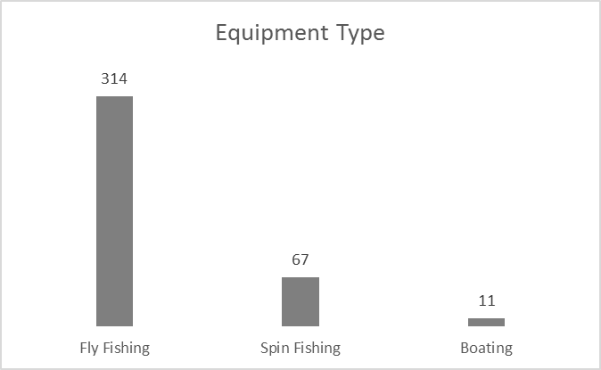

Figure 1. 2016 River user equipment type.

*Footwear Choice*

42% of fly anglers used felt sole waders, the same percentage as 2015 (Figure 2). Other footwear choices included rubber and rubber with spikes. A small percentage of fly anglers surveyed were wet-wading or not entering the water. The data from 2016 show that, as with 2014 and 2015 data, fly anglers are using a mix of rubber and spiked sole wading boots (Figure 3). Overall, approximately 58% of fly anglers were choosing non-felt sole waders.

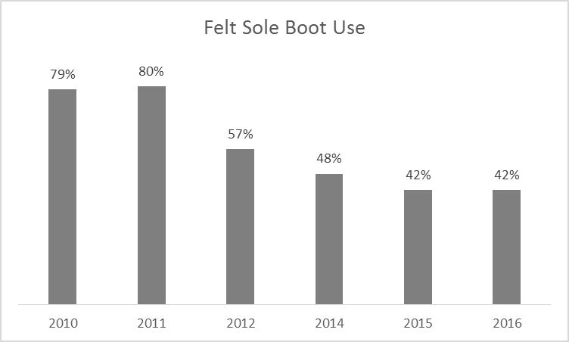

Figure 2. Comparison of felt-sole wader use for each year a survey was administered.

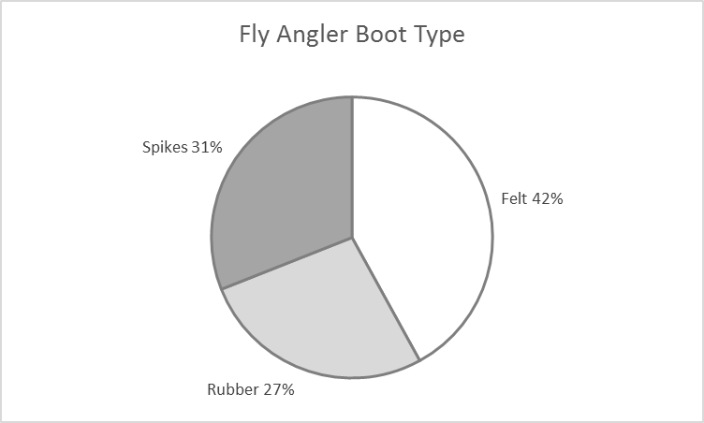

Figure 3. 2016 fly angler footwear choice.

*Cleaning Methods*

A total of 178 (57.6%) of river users wearing or using equipment that could spread AIS (n=309) surveyed actively practiced AIS spread-prevention methods before entering the river. This includes cleaning using salt, bleach, detergent, hot water, freezing items solid, wet wading, or only using their gear in the Ausable River. A total of 122 (39.5%) river users passively practiced AIS spread-prevention by allowing their gear to dry for 48 hours. A total of 9 (2.9%) did not clean their gear or let it dry for 48 hours (Figure 4). Figure 5 shows all prevention methods used by anglers and boaters.

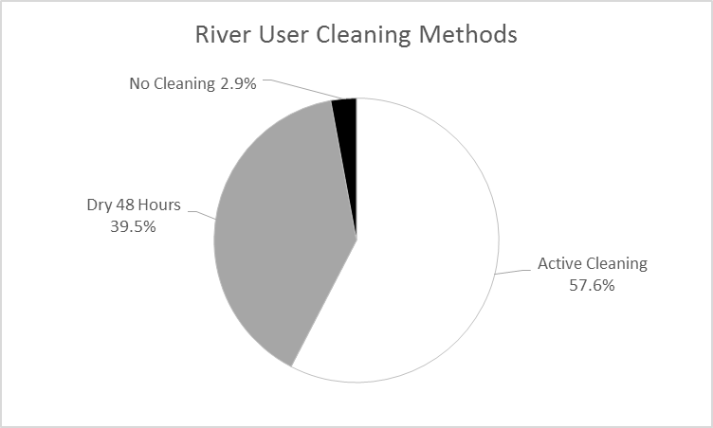

Figure 4. Active and passive cleaning methods for river users.

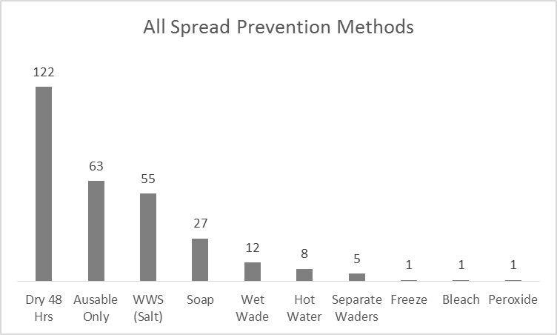

Figure 5. All spread prevention methods for 2016 and number of times they were used.

*Invasive Species Infestations*

During the 2015 season, the river steward discovered 13 invasive plant infestations in the Ausable River watershed. In 2016, no new infestations were found, therefore, the river steward focused on updating the information on already existing infestations. The three large infestations of Japanese knotweed that were discovered in Au Sable Forks in 2015 are still healthy and growing. In 2015, purple loosestrife infestations on Route 86, River Road, and at Whiteface Ski Area were identified by the river steward and were removed by another agency. These infestations did not return in 2016. Scatterings of purple loosestrife that were present in 2015 in Ausable Forks were absent in 2016. Purple loosestrife is a wetland plant and the exceptionally dry season could have limited its growth and spread. Cup plant is still well established on the East Branch of the river.

*Bait Shop Survey*

Updates were made to the 2015 bait shop survey (Table 2). One location, the SUNOCO in Ray Brook, was closed. A new gas station is being built and while it is unlikely they will sell bait, the river steward will check once it opens. In Wilmington, the Village Hardware store was updated and now sells live bait that the Little Supermarket sold. All locations that did not have proper bait disposal signage were given the option to call NYS DEC for materials.

Table 2. 2016 Updated Bait Shop Survey data.

|  |  |  |  |
| --- | --- | --- | --- |
| **Retailer Name** | **Location** | **Bait Sold** | **Proper Disposal Education** |
| Little Supermarket/Village Hardware | Wilmington | worms and night crawlers | No |
| SUNOCO | Ray Brook | Not in business | – |
| Blue Line Sports LLC | Saranac Lake | minnows, trout worms, night crawlers, shiners, billies, suckers | No |
| River Road Bait & Tackle | Bloomingdale | night crawlers, trout worms, minnows, shiners | No |
| C & S Bait & Tackle | Saranac | Not in business | – |
| Saranac Lake Marina | Saranac Lake | worms | – |
| Adirondack Outdoor Co. | Lewis | dace, minnows, sucker, shiners, night crawlers, salted minnows | No |
| Cliff’s RT 3 Sport Shop | Saranac | Not in business | – |

*Additional Outreach*

In addition to placing informational brochures on wader wash stations, the river steward distributed them and other information on AIS at farmer’s markets, EMS Club Days, Two Fly Fishing Tournament, US National Fly Fishing Championship, ADK Trail Run, Adirondack Waterfest, Festival of the Colors, and other local/AsRA events. The steward also delivered a presentation on the River Steward Program at the Boquet River Salmon Symposium. Over 300 people were engaged by the river steward at the various events.

**Discussion**

The 2016 river steward season continued to build upon the work done in the previous season and by the four previous river stewards. New information comes to light every year and continues to put AIS spread awareness into a different perspective.

As with previous years, felt-soled waders are still being used by anglers. The trend has been decreasing over the years but has plateaued this year (Figure 2). As in the previous year, some anglers did discuss that they have moved away from felt soles because of sales bans in other states, particularly Vermont. However, the recent lift on the ban might cause an increase in felt sole usage in the future. Felt sole use will most likely continue to be a popular choice because of its effectiveness on slippery rocks. The use of spiked boots has increased slightly (Figure 3) which provides a better grip than un-studded rubber, however until there is an alternative similar enough to the experience of felt soles, we expect felt sole use will most likely continue to decline slightly or even rise over coming years.

The percentage of users drying their gear for 48 hours or more decreased this year (Figure 4). This is good, considering that drying times for complete mortality of AIS is still relatively unknown, and the river steward has adapted her message to reflect this. While 48 hours is a good estimate, there are other factors such as humidity that can’t be controlled and can cause gear to not completely dry. More anglers are also using soap and salt to clean their gear which is the most effective method for eliminating AIS (Figure 5). The increase in the use of wader wash stations from 2015 could be due to the new location at Quarry Pool (Table 1), the map of the station locations in the AIS “Check, Clean, Dry” brochure (Appendix I), or the continued education provided by the river steward about their use.

During the river user survey and streamside education, when anglers reported they did not actively clean their gear and only allowed their gear to dry for 48 hours, the river steward made sure to emphasize that it is advisable to use drying in combination with other cleaning methods. This one element emphasizes the usefulness of the River Steward program – to continue education and increase awareness among anglers about AIS spread prevention methods. It also emphasizes the need for continued research in understanding the most effective ways to prevent AIS spread.

A small number of anglers (4.5%, n=14) surveyed had previously fished in a water body with confirmed observations of didymo, a 0.5% decrease from 2015. These water bodies included the Battenkill, Connecticut, Delaware, and Farmington rivers. Most of the anglers had traveled and therefore their gear had dried for more than 48 hours, however as previously discussed this still may not allow for complete drying of gear and subsequent AIS mortality. As with the previous year, the river steward noted that many anglers also knew of didymo, but many still believed it to be an invasive, most likely due to how recent the research that supports didymo as a native nuisance species is. This is in part due to the publicity that didymo received after large blooms were recorded in New Zealand streams. Alarms were raised and didymo was identified by many as a non-native invasive. While the diatom is an effective invader, research has now made clear that it is native to parts of North America. While EPA and other federal resources make this clear, NYS DEC continues to label didymo as a non-native invasive thus adding to confusion.

Wader wash stations continue to be very successful. The river steward cleaned the WWS weekly, sometimes more often if it was a particularly busy weekend. In 2014, approximately 22% of river users used salt to clean their gear. This dipped to 10% in 2015, but has risen again to 17% in 2016. This suggests that the stations are still extremely valuable to have on the river. Increased use of the WWS from 2015 could be due to the new location at Quarry Pool, and the relocation of the Whiteface station to the other end of the parking lot.

There were no new invasive species infestations found in the Ausable watershed by the river steward. Three large Japanese knotweed plants were still thriving in Ausable Forks. Purple loosestrife plants that were removed by the river steward and other organizations in 2015 did not return. In addition, purple loosestrife plants that had not been removed were no longer present. This could be due to the extreme dry conditions which prevented the wetland invasive from growing. In 2015 the river steward attended an APIPP training on the removal of terrestrial invasive species. Next year the steward will apply that knowledge and help homeowners who live along the river remove invasive infestations.

**Conclusions and Recommendations**

2016 was a successful year for the River Steward program. The river steward continues to educate and reach out to the public in a variety of ways and is including new and more diverse groups of river users.

The legacy of past contributors continues to be evident. The 2015 river steward reported meeting with anglers who discussed speaking with and being influenced by previous river stewards and that has continued through the 2016 season. There is continued support from river users and local businesses for the River Steward Program.

Positive comments from river users, the data collected this year showing high amounts of anglers utilizing drying as their only gear cleaning practice, and the ongoing use of felt soled waders suggests that there is still a need for the river steward to continue education and outreach efforts. Future projects for the river steward include adapting the river user survey to target clients of local fly shops and guides and piloting a homeowner’s kit that will allow residents along the river to remove invasive plant infestations.

As the River Steward program continues to expand, it is important to continue to learn of AIS spread prevention methods in other river systems. The river steward should continue to attend meeting and workshops on AIS identification, spread prevention, and outreach methods. Continuing to review regulations enacted in other states and municipalities and how they communicate with anglers will further the knowledge and value of AsRA’s river steward.

**Appendix Attachments**

1. “Check-Clean-Dry” Brochure with Wader Wash Station Map
2. 2016 River User Survey
3. Wader Wash Station Informational Sign
4. Selection of Survey Data

Appendix I: “Check-Clean-Dry” Brochure with WWS Map

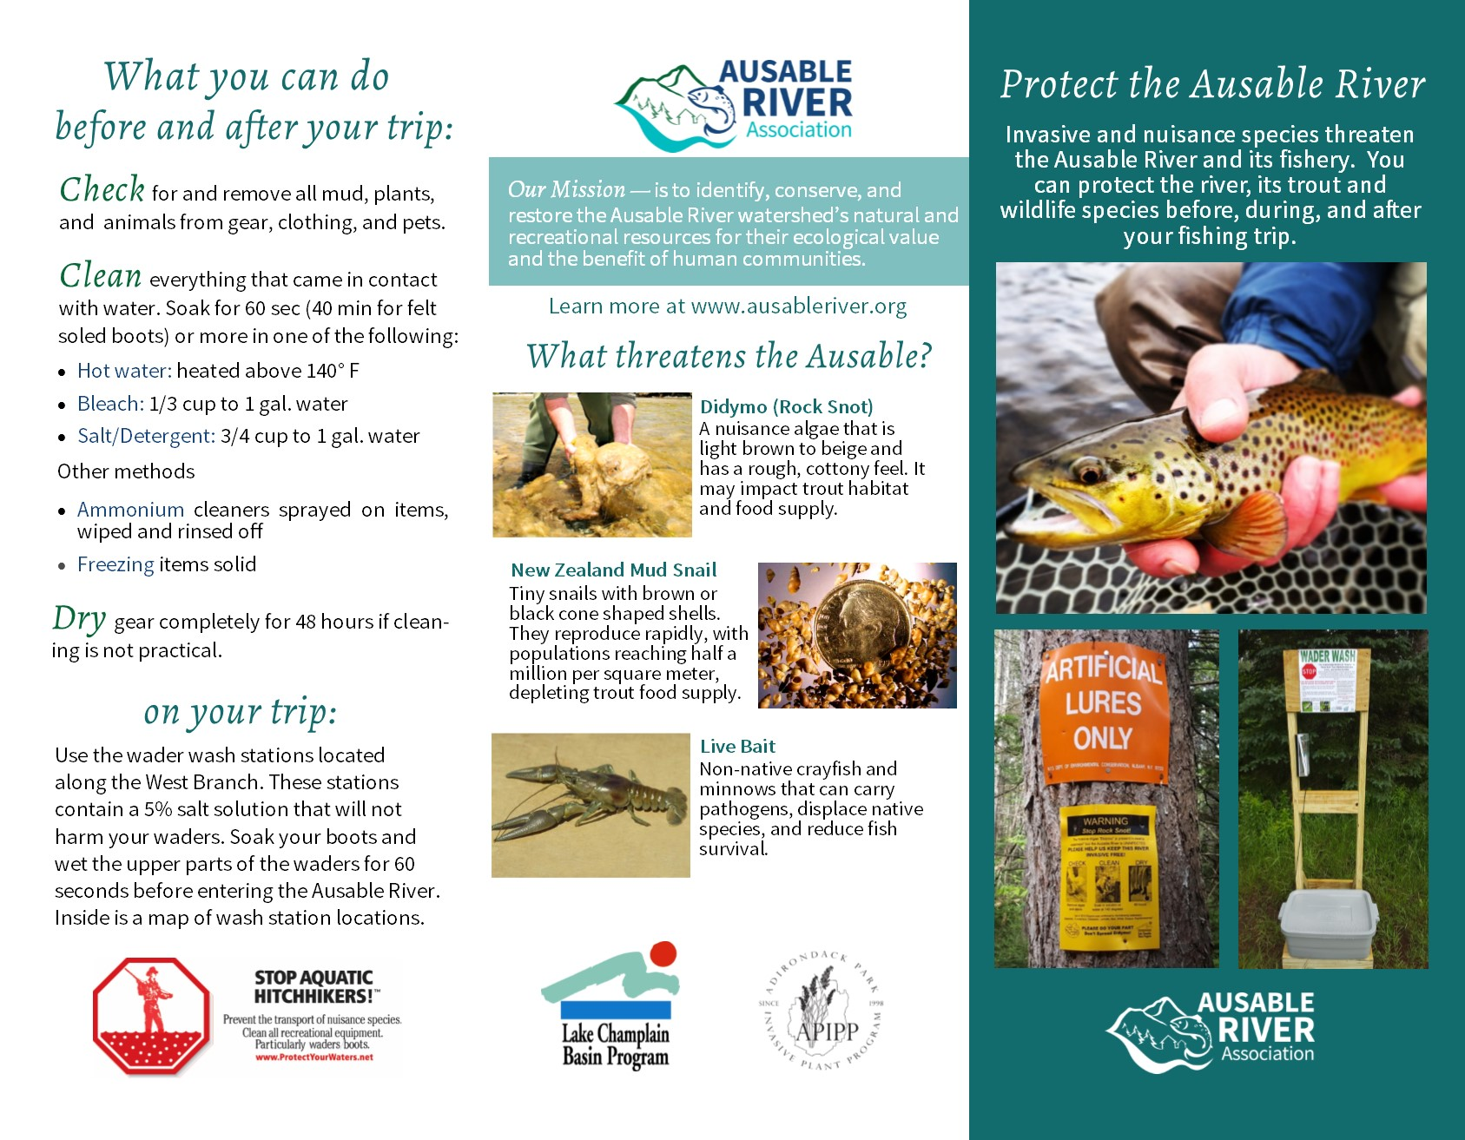

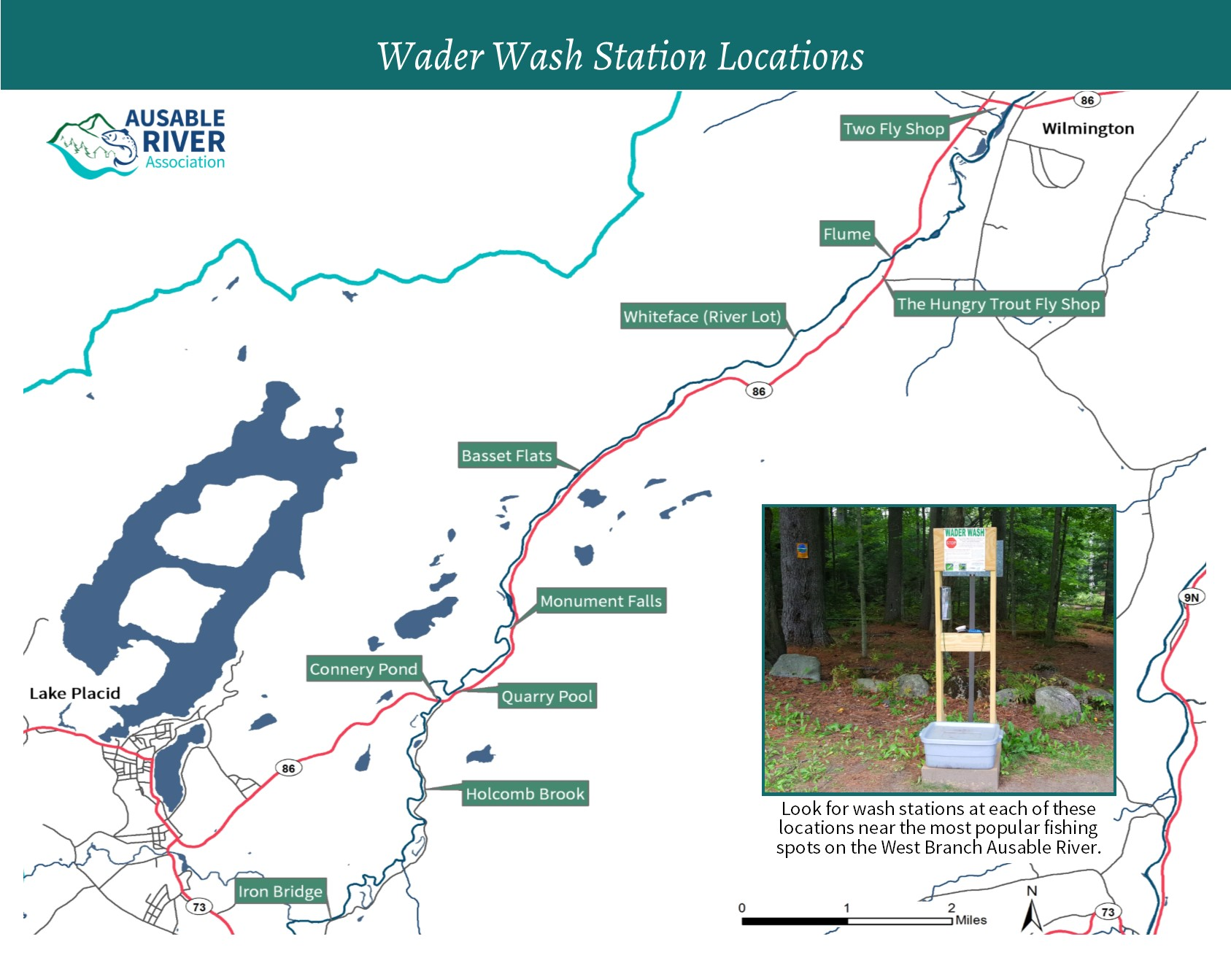

Appendix II: 2016 river user survey data sheet

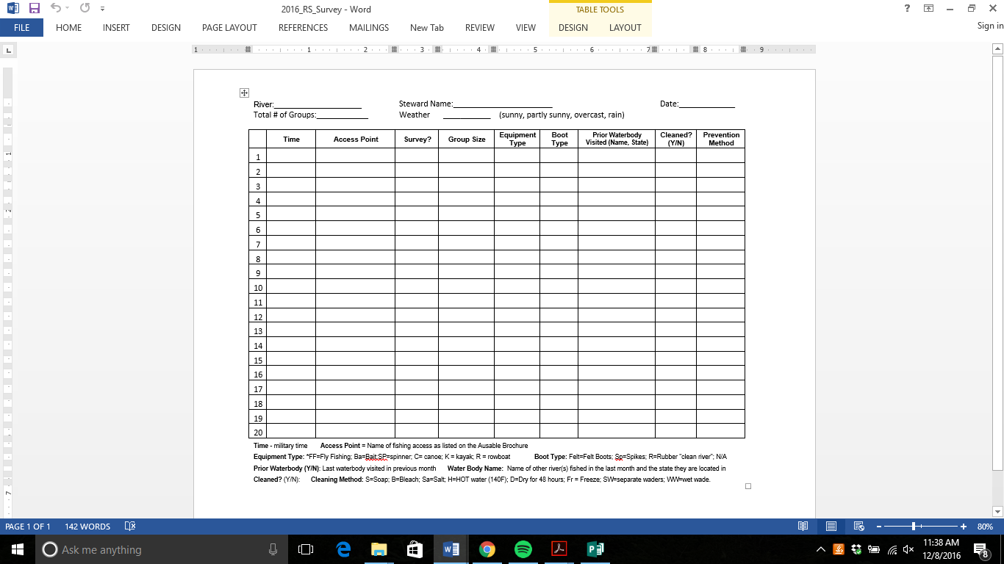

Appendix III: Wader Wash Station Sign

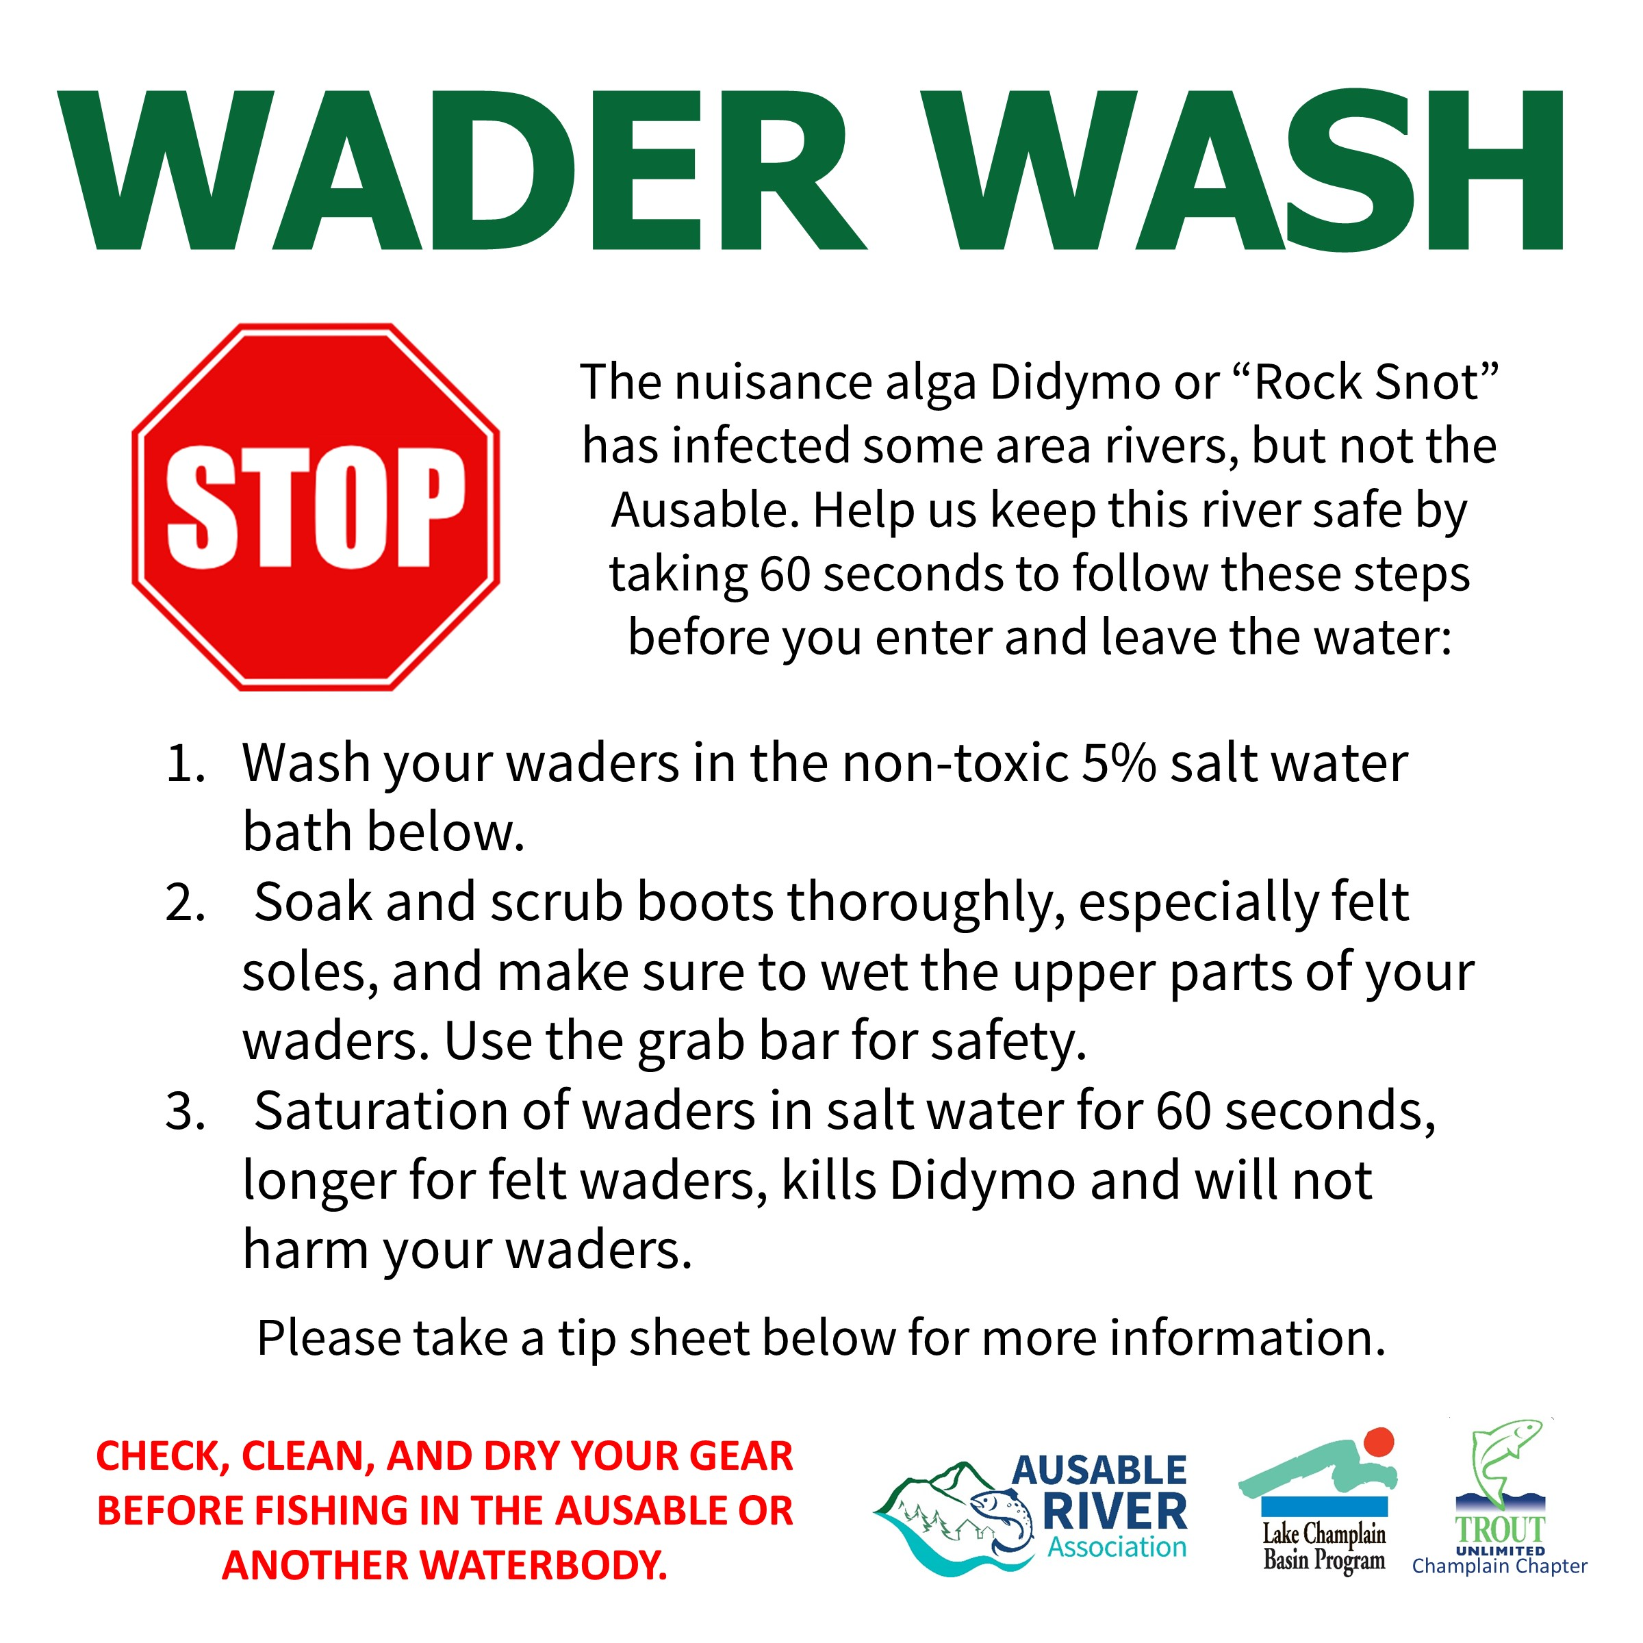

Appendix IV: Selection of Survey Data

