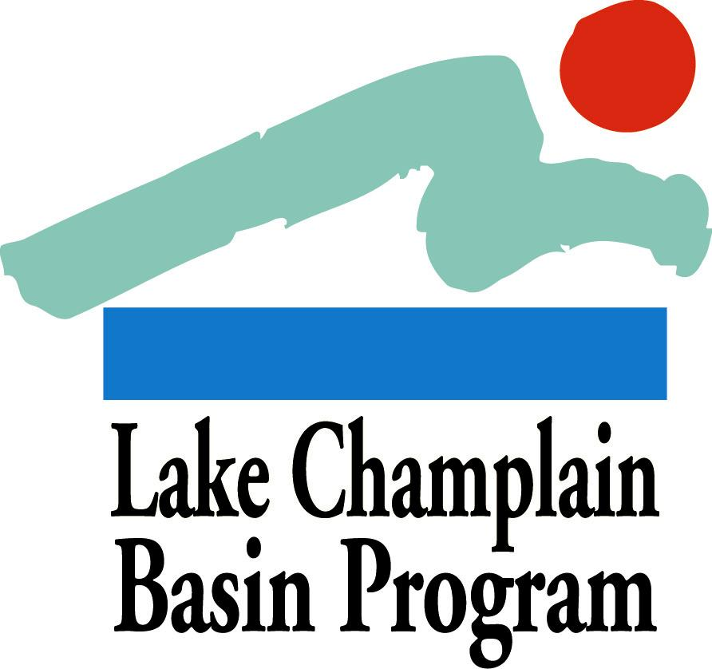

2013 Pollution Prevention Grants:

APPLICATION FORM

Applications must use the format below and provide all of the information requested to be considered for review.

Summary Page
On a single page, please provide the following information in the order shown:

Project Name/Title:

Project Category: Pollution Prevention

Contact Information:

Name of Contact Person:
Authorized Signatory and Title (if different from Contact Person):
Organization:
Mailing Address:
Phone and FAX numbers:
Electronic Mail Address:

Eligibility: Please list all of your organization’s current Lake Champlain Basin Program grants. Any organization with an existing award that has overdue workplans, reports, or other deliverables is ineligible and should not apply.

All new projects will be required to submit a workplan within sixty days after award notifications are made. Projects must be initiated no more than six months after award notification. If these deadline specifications are not met then awards will be lost.

Amount of LCBP Request: ($15,000 maximum)

Organization Mission Statement: (3-5 sentences)

Brief Project Summary: Please describe your project in 3-5 sentences

Project Outcome/Deliverable: Please provide one sentence describing measurable project outcomes.

□ I have read the QAPP guidelines and expect that this proposed task

□ will require a QAPP

□ will not require a QAPP
Application Questions
Please answer the following questions in order, using no more than 3 pages combined (12 point Times New Roman (or equivalent) font or larger, minimum 1 inch margin on all sides). Complete applications should be no longer than 5 pages in length (1 summary page, 3 pages for application questions/answers, 1 budget page). Additional pages, with the exception of letters of support (3 maximum) will NOT be reviewed.

Please include both the questions and your answers in the narrative, which should describe your project as directly and concisely as possible. The review committee will evaluate your application based on your answers to these questions, according to the criteria listed in the Grant Guidelines.
- Describe your project and document the need for this work to be accomplished. If part of a larger project, please describe in detail the portion of the project for which you are seeking LCBP funding. Are you aware of other organizations doing similar work? If your project will take place on private land, how will it benefit the broader community?
- Explain how your project addresses pollution prevention priorities or any of the other priorities in Opportunities for Action. Identify measurable environmental outcomes from your project (e.g. area of re-vegetated stream bank, number of rain barrels constructed, number of nutrient management plans developed).
- Please use the example format below to describe your project objectives, tasks to fulfill these objectives, deliverables produced by each task, and timeline for task completion.

Project Objective, Task, Deliverable and Timeline Table Format (please fill in for your application)
Task # | Objective | Task Title | Deliverable | Timeline
0 | Develop a QAPP | Describe quality assurance procedures that will maintain project performance. | QAPP approval | April 2014
1 | Determine appropriate location(s) for 100’ of riparian buffer | Meet with landowners of 3 potential locations (identified in a previous project), determine interest, and sign agreement with landowner(s). | List and map of project sites | May 2014
2 | Plan planting(s) for fall | Develop planting plan, contact volunteers and schools, purchase supplies, schedule planting date(s). | Planting plan, invoice for supplies | July-August 2014
3 | Implement planting project(s) | Implement plantings with volunteers. Contact local media and provide press releases. | 100’ of re-vegetated riparian habitat | September- October 2014
4 | Complete final report | Compile project summary, plans, articles, photographs. | Final report | December 2014
- Please explain the techniques and methods you and your partners will use to complete the project tasks. Are there feasibility issues to be worked out (permits needed, landowner permission, or technical issues)? Please explain.
- Describe your experience with similar projects. Who will be involved in the proposed project (staff, volunteers, board members)? Does your project involve the local community?
- Complete a Budget Table, based on the guidelines provided in Section C, below. The total funding request must be within the limit of the grant category. Vague or inflated budgets will not be competitive.

C. Budget Table and Justification
Please use the format below for your budget table.
- If the LCBP request is part of a larger project, please indicate the estimated total project value and the funding source(s) for the entire project.
- All expenses should be placed into one of the following major categories:
  - Direct Costs - subcategories include: Personnel (including fringe benefits), Supplies, Contracts, Equipment, and Travel.
  - Indirect Costs – include general office and operating expenses, insurance, bookkeeping, etc. Please refer to the Grant Guidelines for more information about direct and indirect costs, eligible expenses, and matching contributions. Please note that LCBP’s policy for indirect project costs is a maximum of 21% of the total project budget.
- If your project includes several tasks, it is helpful for each task’s budget to be broken out separately from the other tasks.
- List additional specific expense categories where appropriate as indicated.
- For projects requiring a QAPP, LCBP will not pay for any data collection or analysis activities started prior to development and receipt of a fully-approved QAPP
- Budget items should be divided into funding sources as shown in the budget table. At minimum, show which items will be covered by the LCBP grant and which items will be part of your matching contribution (if matching contributions will be used). List other sources of funding that are not being used as match (such as other federal funds) below your budget table, as shown.
- In addition to the budget table, please include a brief justification for each line in your budget, as in the following example:
Budget Justification:
- Project Coordinator: supports staffing for oversight of project activities, 50 hours @ $18/hr.
- Volunteers: streambank plantings, etc., 25 hours @ $10/hr.
Project Budget Table Format (Dollar values for illustration only.)
Expense | LCBP Grant Request | Non-Federal  Matching Contribution | Totals
DIRECT Costs:
Personnel
Project Coordinator | $900 | $100 | $1000
Volunteers |  | $250 | $250
(Add specific lines as needed)
Travel (Add specific lines as needed) | $100 | $100 | $200
Supplies/Materials
Printing | $250 |  | $250
Mailing | $75 |  | $75
(Add specific lines as needed)
Contracts (Add specific lines as needed)
Equipment (Add specific lines as needed)
Other (please specify)
INDIRECT Costs: | $100 | $100 | $200
Totals | $1,425 | $550 | $1,975
*Additional Federal funds supporting this project include $500 from an EPA grant.

D. Letters of Support
Attach any required letters of participation and up to three letters of support to your application. Please be sure that the letters are signed by the appropriate authors. Do not provide more than three letters of support with your application. Only the first three letters of support will be included in your grant evaluation. Letters of support received separately from the application will not be included in the application review. See the Grant Guidelines for more information.

E. Submission Process
- Please submit ten (10) hardcopies of each application to the LCBP address listed below. In addition, please submit the electronic versions of your summary page, application questions, and budget page either on compact disk or by email to grants@lcbp.org.
- Both hardcopies and electronic versions must be submitted by the due date.

Applications must be received in the Basin Program Office by
4:30 PM Thursday November 14, 2013.

Successful applicants will be notified by early January, 2104.

Send completed applications (hard copy and electronic version) to grants@lcbp.org. Direct all questions to Eric Howe, Technical Coordinator (ehowe@lcbp.org ).

PHONE: 800-468-5227 (Toll free in VT/NY) or 802-372-3213

ADDRESS: Lake Champlain Basin Program, 54 West Shore Road, Grand Isle, VT 05458

