**Aquatic Invasive Species River Steward**

**NEI Job Code: 0100-306-010 Project Code: L-2015-045**

**Project Manager: Kelley Tucker**

**Additional Project Oversight: Brendan Wiltse**

**River Steward: Nicole Pionteck**





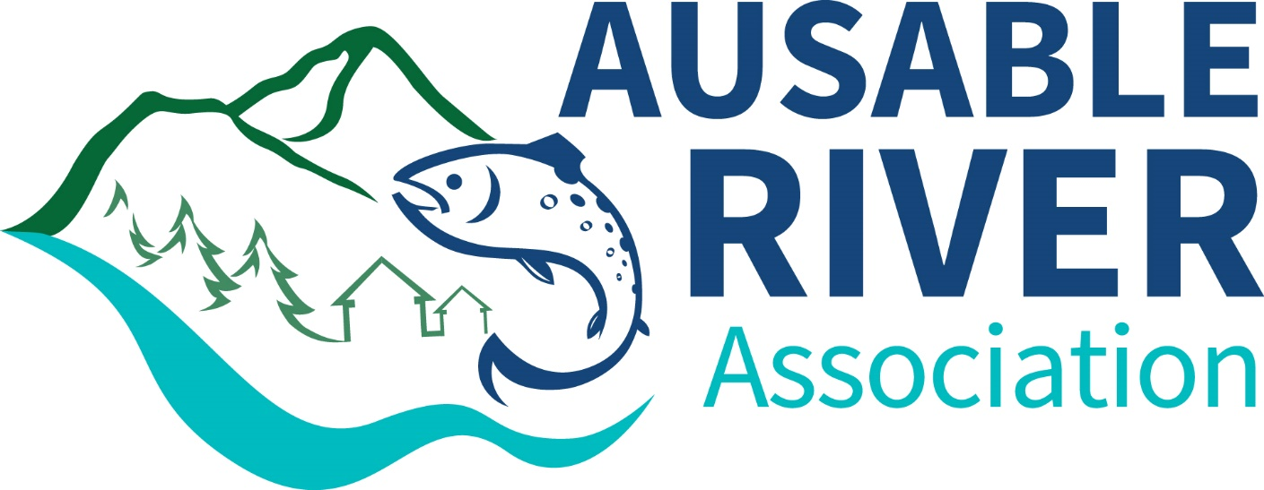

Final Report

By

Nicole Pionteck

December 2015

This is the final report for work done by the Ausable River Association (AsRA) to fulfill the responsibilities of the grant “Aquatic Invasive Species River Steward for Central Champlain Region of NY, “ NEI Job Code: 0100-306-010 and Project Code: L-2015-045. The report outlines all work performed between May 22, 2015 and October 12, 2015.

**Introduction**

Aquatic invasive species (AIS) that disturb river systems are quickly making their way into the Lake Champlain Basin. The Ausable River, though currently healthy, is stressed, and cannot afford to be affected by nuisance species or invaders. AIS such as New Zealand mud snail, rusty crayfish, and fish diseases, and nuisance species such as didymo threaten both the Ausable River’s ecosystems and the region’s tourism. The introduction of these invasive/nuisance species, combined with already established terrestrial invasive species, could have a devastating impact on the river. AIS affect water quality, habitat diversity, and nutrient processing, putting stress on native species such as brook trout. The Ausable River brings $3.8 million to the region annually through its world class trout fishing tourism, supporting local fly shops, fishing guides, and other businesses. The Ausable’s beautiful scenery also attracts paddlers and hikers to the area. To help protect the Ausable River from AIS, the Ausable River Association’s (AsRA) River Steward program performs education and outreach to river users and conducts monitoring aimed at early detection, creating awareness and helping to prevent the spread of invasive species.

In 2015, with funding from NEIWPCC awarded through LCBP, the Ausable River Association (AsRA) hired, trained, and deployed an AIS river steward on the Ausable River in New York State’s central Champlain region. This highly successful program was implemented during the summers of 2010-12 and 2014. The River Steward program works to protect the Ausable River, and the many lakes within its watershed, from aquatic invasive species through spread prevention. Spread prevention relies on public education, early detection of species, and rapid response to new threats. The river steward traveled throughout the Ausable region, delivering the “Check, Clean, Dry” message to river users, the general public, visitor bureaus, and local fly shops. Tip sheets and other educational materials were distributed broadly. Seven wader wash stations were maintained at popular fishing access sites along the river. The river steward monitored and reported new terrestrial invasive species infestations and removed them when feasible.

Results are measured in number of anglers, river users, general public, fly shops and visitor bureaus engaged and educated. An angler/river user survey was administered on the river which asked what gear type was used, what body of water the user visited previously, and what steps they take to clean their gear. Data from the survey is compiled for use in AsRA’s organizational planning and to inform our partners of the results. Number of invasive species infestations identified and removed was also recorded, including river miles surveyed. Also for this year, the river steward surveyed bait shops convenient to the river to determine what kind of bait is sold and if the sellers provide a bait disposal message to their customers.

Anglers are often considered the major vector for transporting river-based AIS. Because many nonnative, nuisance, and invasive species are small or invisible to the naked eye, such as didymo and New Zealand mud snail, they are difficult to detect and remove from gear. This means that the type of gear anglers choose influences AIS spread prevention. Felt soled boots are a popular choice for anglers because they provide traction on slippery rocks, however they are difficult to clean and dry, compared to non-felt soles. This makes them a potential vector for AIS transport and therefore alternatives such as “clean stream” boots (made with rubber with spikes and minimal absorbent materials) are being promoted by gear companies and state regulators. Although the gear is being improved, it is still up to the angler to understand the threat of AIS, buy the equipment, and implement proper cleaning techniques.

This was the fifth successful year of the River Steward program. The position has been refined over this time to address changing needs, to adapt the AIS message to the public and the angling community, and to better determine the extent of invasive species within the Ausable River watershed. Work is focused on the high use areas of the Ausable River (targeting fly anglers, spin anglers, and paddlers), public events (farmer’s markets, fairs, lake association meetings), and along river segments vulnerable to invasive species introductions. The steward position has become a full-time, funding dependent position at AsRA. Invasive species monitoring, spread prevention, eradication, and outreach remain at the core of the position description that more generally will monitor river health and provide data and information in multiple formats to the public.

The river steward faced several challenges this year. First, surveying began later in the season than previous years because of late timing of the hire and the need for the steward to move to the area. Weather conditions also presented a challenge this season. The river level was very high at the start of surveying, and was then extremely low after more than a month of no rain near the end of the season. The varying water levels made it more difficult for the river steward to predict when there would be the most anglers in the river.

**Methods**

On May 29, the QAPP for the river steward position was approved and the hiring process was under way. In June 2015, AsRA’s executive director hired Nicole Pionteck to fill the river steward role under the 2015 grant. Nicole graduated from SUNY College of Environmental Science and Forestry with a BS in Environmental Science with a focus in Watershed Science. Nicole began training mid-June, touring the river with staff and past river steward Carrianne Pershyn. She quickly became familiarized with AsRA, the Ausable watershed, and responsibilities of the river steward. Nicole was familiar with aquatic invasive species through her internship working on Owasco Lake during the summer of 2014. She also attended an Aquatic Invasive Species training program provided by the Adirondack Park Invasive Plant Program (APIPP). Nicole’s education in watershed science and experience working as an Owasco Lake Watershed Inspector allowed her to effectively communicate with river users about the threat of invasive species to the Ausable River and what effects they could have on the river’s ecosystem.

The river steward was active on the river beginning on July 2, and continuing through October 12. The steward’s primary responsibilities included:

1. Performing streamside, local business, and entry point education, distributing spread prevention educational materials and administering the river user survey;
2. Maintaining wader wash stations;
3. Performing visual observations of waterways for aquatic and terrestrial invasive species infestations;
4. Visiting area bait and tackle shops to assess types of live bait sold;
5. Attending public events, educating about invasive species and spread prevention.

Several print materials were used by the river steward. The primary outreach material was the “Check, Clean, Dry” tip sheet (Appendix I). The tip sheets are 4 x 9” double sided, full color rack cards that were designed in 2014 by AsRA staff and updated this year to match AsRA’s new branding. These rack cards give a variety of options on how to clean gear to remove nuisance or invasive species. Information on three main invasive and nuisance species threatening the Ausable (didymo, New Zealand mud snail, and rusty crayfish) was also on the cards. These were attached to wader wash stations, distributed at events, and available at local fly and retail shops. In addition to the rack cards, the river steward also developed a wader wash station location map (Appendix II). This map was made into a brochure that included a condensed version of the information on the rack cards and was distributed similarly to the rack cards.

The river steward conducted a streamside survey (Appendix III) of a variety of river users including fly fishermen, spin fishermen, kayakers, and canoers. The survey was slightly different from last year and no longer collects specific information on invasive species knowledge, but continues to collect data on type of gear, previous water bodies fished in, and cleaning practices. The river steward took notes if someone mentioned knowing about specific invasive or nuisance species.

This year, the NYS DEC approved placement of three additional wader wash stations on the Ausable. AsRA built seven new, more compact wash stations and placed these along the West Branch at the following locations:

1. Iron Bridge on River Road
2. Holcomb Brook
3. Connery Pond Parking (Route 86 and River Road)
4. Monument Falls
5. Basset Flats
6. Whiteface Parking Lot
7. Flume Trailhead

Although smaller, the wash stations remained otherwise the same as in previous years, consisting of a five-gallon bin with a 5% non-toxic salt solution, scrubbing brush, timer, rack cards, and an information sign (Appendix IV). The river steward maintained two additional wash stations at the Hungry Trout fly shop and AuSable Two Fly Shop.

During slow times on the river, the steward looked for invasive species infestations in the river, on its banks, and at other locations in the watershed. Infestations were identified, recorded on Weed Information Management System (WIMS) data sheets (Appendix V), sent to the Adirondack Park Invasive Plant Program (APIPP), and recorded on the NYS DEC website imapinvasives.org. At the end of the season, the river steward created a map of the discovered infestations (Figure 7). A total of 100 miles of roadway were surveyed and 13 new invasive species infestations were found in the Ausable River watershed. Of these, the three species found were Japanese knotweed, purple loosestrife, and Indian cup plant. In three cases, the purple loosestrife was removed by hand and properly disposed. This year, the steward also surveyed local bait shops to determine what type of bait is sold, if they provide education on their proper disposal, and whether they provide information on invasive species. Trash was picked up at the popular fishing access sites during slow times.

The river steward visited multiple local businesses and attended various events in the region over the course of the summer. This includes four lake association meetings, three farmer’s markets in Lake Placid, Keene Valley, and Saranac Lake, the Essex County Fair, ADK Habitat Awareness Day at the Adirondack Wildlife Refuge in Wilmington, and AsRA’s Ride for the River and Friendraiser events. Three fly shops, the Whiteface Visitor’s Bureau, and one retail shop were also visited. At events, meetings, and shops she distributed information rack cards and provided information about invasive species and spread prevention. AsRA’s Science and Stewardship Director Brendan Wiltse performed outreach by assisting with training at two of the Adirondack Mountain Club’s Backcountry Waters Monitoring training programs.

**2015 Results**

The river steward collected all data in the field at the designated river access locations listed in Table 1. During the survey, the steward effectively delivered the AIS spread prevention message, following a format developed by past river stewards and adapting it depending on the type of river user and their survey answers. She used her best judgment about when to engage river users as to not inconvenience them, but attempted to deliver the message prior to the individual entering the water to fish or recreate. During the survey, answers were recorded on a paper form following the QAPP. The river steward then entered the data into a Microsoft Excel spreadsheet and submitted them to the river steward manager, AsRA’s Science and Stewardship Director, to check for accuracy. The manager was responsible for receiving, saving and storing the electronic data and checking the accuracy of the electronic data entry against the field survey forms. The manager randomly reviewed 10-20% of the river steward’s field and electronic data sheets. Any inconsistencies were shown to the steward to prevent further inaccuracies and correct the data point. The weekly review was undertaken of both the field survey forms and the electronically submitted data. This allowed for the quick correction or clarification of improperly entered, confusing, or incomplete data and enabled the river steward manager to meet with and correct any data entry issues with the river steward quickly. At the close of the field season, all data were again reviewed to ensure consistency. Per the QAPP, the data will be stored in Excel format and will be sent to the LCBP Project Officer upon project completion to be stored on the LCBP office computers for a minimum of 5 years.

River user surveys (n=406) were completed on 45 days between July 2 and October 12, 2015. Surveys were taken at 11 locations along the Ausable River, from the ski jumps in Lake Placid to Signor Lane in Ausable Acres (Table 1).

Table 1. 2015 Survey locations on the Ausable River.

|  |  |
| --- | --- |
| **Survey Location** | **Surveys Completed** |
| Iron Bridge | 8 |
| Holcomb Pond outlet | 9 |
| River Rd. | 20 |
| Connery Pond parking (RT-86 bridge) | 41 |
| Quarry Pool | 54 |
| Monument Falls | 48 |
| Shadow Rock Pool | 20 |
| Basset Flats | 43 |
| RT-86 parking areas | 49 |
| Whiteface Mountain | 73 |
| Hungry Trout | 2 |
| Flume Trails parking | 15 |
| Lake Everest/Wilmington Beach | 21 |
| Signor Ln. Ausable Acres | 3 |
| Total | 407 |

*River Users*

83% of river users surveyed were fly anglers. Other user types include spin anglers, kayakers, and canoers (Figure 1).

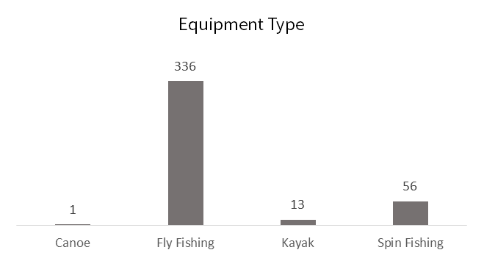

Figure 1. 2015 River user equipment type.

*Footwear Choice*

42% of fly anglers used felt sole waders, a 6% decrease from 2014, and continuing the downward trend since 2011 (Figure 2). Other footwear choices included rubber and rubber with spikes. A small percentage of fly anglers surveyed were wet-wading or not entering the water. The data from 2015 show that, as with 2014 data, fly anglers are using a mix of rubber and spiked sole wading boots (Figure 3). Overall, 58% of fly anglers were choosing non-felt sole waders.

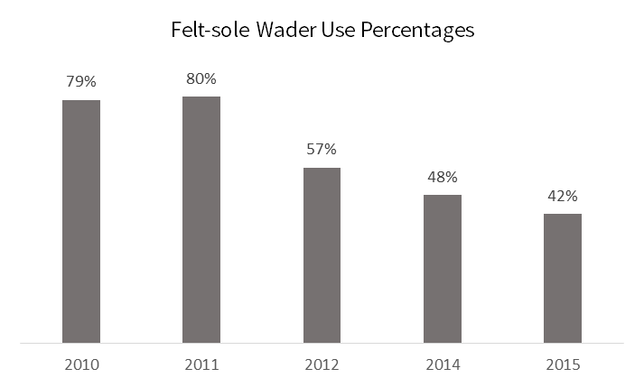

Figure 2. Comparison of felt-sole wader use for each year a survey was administered.

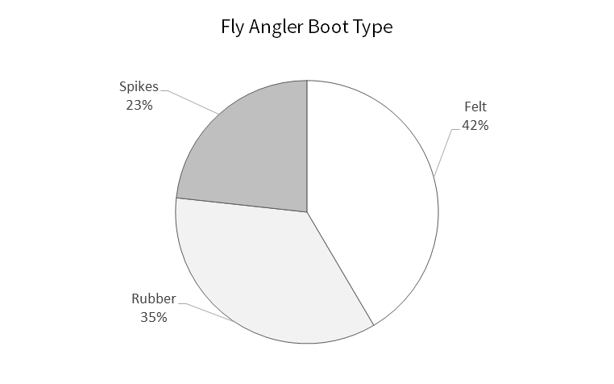

Figure 3. 2015 fly angler footwear choice.

*Cleaning Methods*

A total of 389 (95.8%) of river users surveyed practiced AIS spread-prevention methods between rivers. This includes cleaning, drying for 48 hours, or only using their gear in the Ausable River. However, of the river users that cleaned their equipment, only 40% actively cleaned their gear by using salt, bleach, or detergent, or used Ausable only gear. The other 60% passively prevented AIS spread by allowing their gear to dry for 48 hours or more (Figure 4). Figure 5 shows all prevention methods used by anglers and boaters.

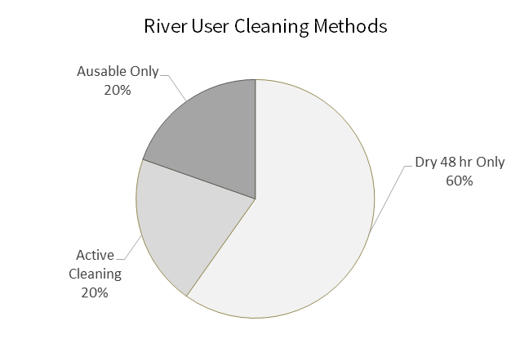

Figure 4. Active and passive cleaning methods for river users. Active cleaning includes using bleach, soap, salt, hot water, or freezing items solid. Percentages do not include users that did not clean their gear.

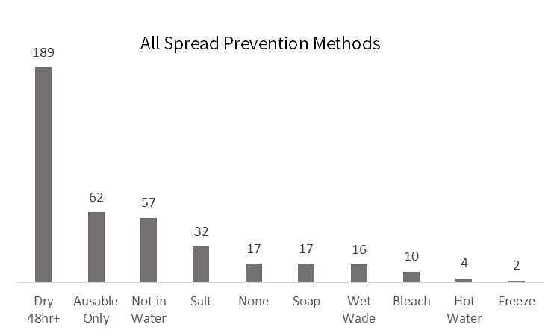

Figure 5. All spread prevention methods for 2015 and number of times they were used.

Cleaning methods varied significantly between 2015 and the two prior year’s data (2012 and 2014). For this season, drying less than 48 hours was not considered a cleaning method as this did not give ample time for AIS to desiccate. Drying for 48 hours or more greatly increased this year, most likely due to how the river steward formulated the question about preferred cleaning methods. Using equipment only in the Ausable has increased slightly, however active cleaning has decreased greatly. Bleach, salt, and soap use has decreased by 29% and use of salt has decreased by 22% since 2014.

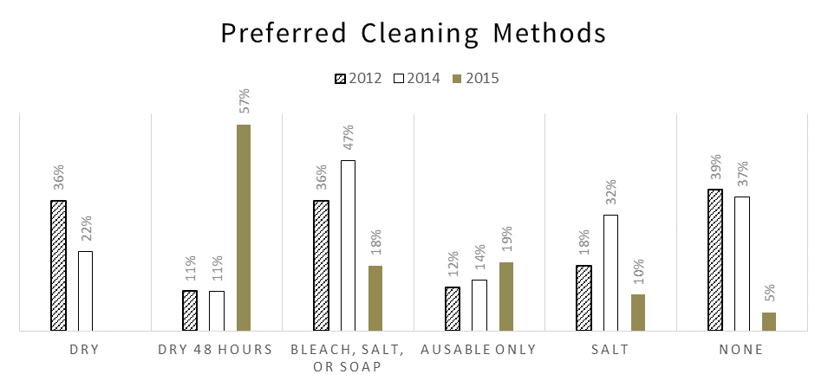

Figure 6. Comparison of river user preferred cleaning methods for 2012, 2014, and 2015. Note that there is no data for drying less than 48 hours for 2015 because this was not considered a cleaning method.

*Invasive Species Infestations*

During the 2015 season, the river steward discovered 13 invasive plant infestations in the Ausable River watershed. Three large infestations of Japanese knotweed were discovered in Au Sable Forks. These plants were unable to be removed, however they were reported to APIPP, imapinvasives.org, and members of the local government in hopes that in the future there will be a plan to remove them. Three purple loosestrife infestations, two on Route 86 near Connery Pond parking and one on Outlook Lane in Wilmington, were removed by hand by the river steward and disposed of properly. Other purple loosestrife infestations on Route 86, River Road, and at Wilmington Ski Area were too large for the river steward to remove by hand. Cup plant was also recorded on the East Branch of the river, although it is already known that this infestation is well established. Locations of infestations discovered by the river steward can be found in Figure 7.

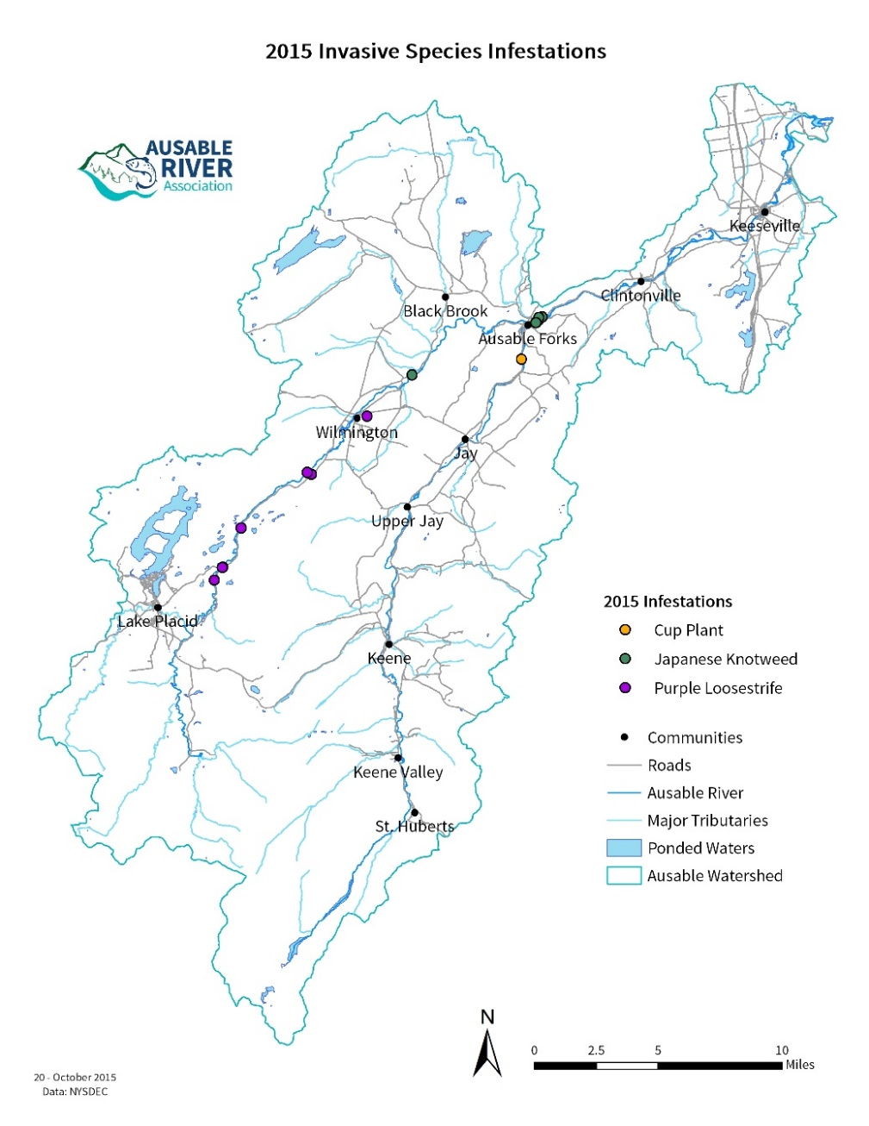

Figure 7. 2015 invasive plant species infestations discovered by the river steward.

*Bait Shop Survey*

Eight retailers selling fishing bait were contacted by the river steward. Of these, two said they were no longer selling bait and two only sold worms or night crawlers. The other four sold similar types of bait fish and worms/night crawlers. The retailers were also asked if they had signs of or told customers about proper bait disposal. Table 2 shows the results from the survey.

Table 2. 2015 Bait Shop Survey data.

|  |  |  |  |
| --- | --- | --- | --- |
| **Retailer Name** | **Location** | **Bait Sold** | **Proper Disposal Education** |
| Little Supermarket | Wilmington | worms and night crawlers | No |
| SUNOCO | Ray Brook | night crawlers, trout worms, salted minnows, crayfish | No |
| Blue Line Sports LLC | Saranac Lake | minnows, trout worms, night crawlers, shiners, billies, suckers | No |
| River Road Bait & Tackle | Bloomingdale | night crawlers, trout worms, minnows, shiners | No |
| C & S Bait & Tackle | Saranac | Not in business | – |
| Saranac Lake Marina | Saranac Lake | worms | – |
| Adirondack Outdoor Co. | Lewis | dace, minnows, sucker, shiners, night crawlers, salted minnows | No |
| Cliff’s RT 3 Sport Shop | Saranac | Not in business | – |

*Additional Outreach*

In addition to placing informational rack cards on wader wash stations, the river steward also placed them at Lake Everest/Wilmington Beach and distributed them to Wiley’s Flies, Hungry Trout Fly Shop, Au Sable Two Fly Shop, Whiteface Visitor’s Bureau, and The Mountaineer. Rack cards and other information on AIS was brought to the farmer’s markets, Essex County Fair, and other local/AsRA events. Over 200 people were engaged by the river steward at the various events and businesses.

**Discussion**

The 2015 river steward season continued to build upon the work done by the four previous river stewards. Some behavior changes can be seen in the survey results, and new information has been gathered this year that puts AIS spread awareness into a different perspective.

As with previous years, felt-soled waders are still being used by anglers. The trend continues to decrease, but only by a small percentage (Figure 2). Some anglers did discuss that they have moved away from felt soles because of sales bans in other states, particularly Vermont (Figure 3). Some also believed that the sale of felt soles was banned in New York State (NYS). Many anglers did not comment if the non-felt soles were better, but some did say that they liked felt better because it gave them the best grip on the slippery rocks of the Ausable. Until there is an alternative similar enough to the experience of felt soles, or they are banned in NYS, felt sole use will most likely only continue to decline slightly over coming years.

The percentage of users drying their gear for 48 hours or more increased this year (Figure 4). This is likely the result of how the river steward framed the question about respondents’ cleaning habits. If the person had not fished in another body of water recently they usually said their gear had not been used and therefore dried. If this was the case the river steward asked if they used other methods to clean their gear such as bleach, soap, salt, hot water, or freezing, since drying for less than 48 hours is not an acceptable cleaning method by itself. In the future, adjusting the way the cleaning method question is asked may produce results more comparable to the 2012 and 2014 data.

Although most respondents said that their gear had dried for over 48 hours, and therefore it was safe, this meant that they did not actively clean with salt, bleach, or soap. Therefore, during the survey, if the angler answered that they gear had dried for more than 48 hours, the river steward made sure to emphasize that it is advisable to use drying in combination with other cleaning methods (Figures 5 & 6). This one element emphasizes the usefulness of the River Steward program – to continue education and increase awareness among anglers about AIS spread prevention methods.

A recommendation for future years would be to review the current acceptable drying time for desiccation of nuisance or invasive species. This question arose in the context of motorboats at the AIS Outreach workshop at Paul Smiths. Our current sources for the 48 hours include an EPA article from 2007 that states a drying time of at least 48 hours (Spaulding and Elwell 2007), and another study (Kilroy et al. 2006) on Didymo survivability that concludes the following:

“Drying should only be relied upon as a decontamination treatment if great care is taken to actively and completely dry the felt (such as by using a heat source where temperatures around the felt are assured of reaching 30˚C)...Once completely dry, items must remain dry for at least 48 hours before use in another waterway"

There is a clearly demonstrated need for the Ausable River Association to review current methods and outreach materials from other watershed organizations and adapt our educational message for 2016 if needed.

Increased signage and printed material at fishing access sites along the entire length of the Ausable would be beneficial to remind all river users of the importance of AIS prevention. We will review all changes internally and with LCBP, and make adaptations to the rack card and the wader wash instructional signage for 2016. This year, AsRA attempted to work with the Northern Forest Canoe Trail (NFCT) and the NYS DEC to develop updated “Check, Clean, Dry” signs to place along the river. Many of the key sites identified for new signs by AsRA were on state land. Permission to adapt the NFCT sign was denied by DEC because the agency wants all sings to be consistent throughout the state. AsRA will continue to follow NYS DEC progress on signage and advocate for placement at key sites on the Ausable River.

A small number of anglers (5%, n=21) surveyed had previously fished in a water body with confirmed observations of didymo. These water bodies included the Battenkill, Connecticut, Delaware, and Farmington rivers. The percentage of anglers fishing in a water body with confirmed didymo sightings has not changed since 2014. All of the anglers in 2015 had cleaned their gear or let it dry for 48 hours or more before coming to the Ausable. Many also expressed that they knew about didymo, and the risks of spreading it, and therefore took steps to make sure they wouldn’t transport aquatic and nuisance species between bodies of water. Although there was no formal survey question, the river steward felt that many other anglers also knew of didymo and other invasive species.

Half of the boaters surveyed did not clean their boats or let them dry for 48 hours or more (Figure 1). Four kayakers came from lakes that have confirmed sightings of AIS, Cayuga Lake and Middle Saranac Lake. However, they could confirm that there was no visible vegetation attached to their boats. Boaters may pose a larger risk for AIS spread in the river than previously assumed because they can often travel between bodies of water in less than 48 hours, indicating a need for more AIS spread prevention education for this group.

Wader wash stations (WWS) are continuing to be very successful. The river steward cleaned the WWS weekly, sometimes more often if it was a particularly busy weekend. The survey data show that the use of salt as a spread prevention method has decreased by 22% since 2014. All but one of the river users that used salt had used the WWS, which suggests that the stations are still extremely valuable to have on the river. As suggested last year, a WWS was placed at the Whiteface Mountain parking lot. It showed some use, but it is recommended that it be placed at the other end of the parking lot next year where there are fewer vehicles parking for other Whiteface activities and will therefore be more visible and accessible.

There were 13 new invasive species infestations found by the river steward in the Ausable River watershed this year (Figure 7). Most of them were purple loosestrife. Three infestations were hand-removed by the river steward and solarized by placing them in a black garbage bag and exposed to sunlight for a minimum of two weeks to kill the plant and prevent it from re-establishing. Other larger purple loosestrife infestations were removed by other organizations. There were four large Japanese knotweed infestations that were of particular concern, since knotweed is not easily removed. Three of these infestations were directly on the near banks of the Ausable River, and when they spread could displace native vegetation, potentially causing bank instability. AsRA plans on training the river steward on methods to properly eradicate Japanese knotweed infestations in the future. All of the new infestations were reported to APIPP so they could enter the information into their database. The river steward also created an account with imapinvasives.org and input the data there. Also, during slower times, the river steward would walk along the shores checking under hemlock and balsam fir trees for wooly adelgids. Fortunately none were found, but monitoring for this invasive should continue as the wooly adelgids could cause major damage to the Ausable River’s riparian zone. Currently, the West Branch, which is the most popular fishing area, is relatively unaffected by riparian invasive species. However, according to data on imapinvasives.org, the east branch and main stem have numerous infestations. Spreading of these invasive species to all parts of the watershed could have significant impacts on wetlands and shorelines, decreasing overall water quality in the Ausable system.

The bait shop survey was revived for 2015 and faced some challenges. Many of the bait shops researched online are no longer in operation. Also, a few of the shops only sold worms, that while invasive, have not been a focus for our work. The river steward also inquired whether the shops had signs about or told customers how to properly dispose of bait. All of the shops, including the ones that sold bait fish, did not have such signage and did not express that they verbally educated customers. Reaching out to these shops with education and signage may be a future project for the river steward.

This year, the river steward also began establishing relationships with lake associations within the Ausable River watershed to offer information and education about aquatic and terrestrial invasive species. Size and community reach of the associations contacted varied. Mirror Lake Watershed Association of Lake Placid was the largest and most active, and needed little education on the problem of invasive species. Fern Lake Association was also contacted, and they benefitted from the river steward’s presence. They asked questions about looking out for terrestrial invasive species, who to report to, and for more updated information on all invasive species, which the river steward provided.

**Conclusions and Recommendations**

2015 was a successful year for the River Steward program. The river steward continues to educate and reach out to the public in a variety of ways and is including new and more diverse groups of river users.

The legacy of past contributors continues to be evident. The 2015 river steward reported meeting with anglers who discussed speaking with and being influenced by previous river stewards. Many thanked the steward for their work and her efforts helped to keep the Ausable River and trout fishery healthy. They were enthusiastic to express their appreciation for the program and the presence it creates on the river.

Positive comments from river users, the data collected this year showing potentially decreasing gear cleaning practices, and the ongoing use of felt soled waders suggests that there is still a need for the river steward to continue education and outreach efforts.

Future projects for the river steward include walking along sections of the river to map out the extent of invasive and nuisance species. Being in the river will give the steward a better perspective than the current method of roadside surveys. The river steward might also work with NYS DEC to move one or two of the WWS to more active locations such as Quarry Pool. This year’s data also indicates a need to formulate a more consistent way to ask the survey questions, which can be discussed with the previous river steward. The river steward also attended the AIS Outreach Workshop at Paul Smith’s and plans to apply information and resources gathered there to continue to expand and improve the River Steward program.

As the River Steward program continues to expand, it is important to continue to learn of AIS spread prevention methods in other river systems. The river steward should continue to attend meeting and workshops on AIS identification, spread prevention, and outreach methods. Continuing to review regulations enacted in other states and municipalities and how they communicate with anglers will further the knowledge and value of AsRA’s river steward.

**Appendix Attachments**

1. Informational Rack Card
2. Wader Wash Station Map/Brochure
3. 2015 River User Survey
4. Wader Wash Station Informational Sign
5. Weed Information Management System Data
6. Selection of Survey Data

Appendix I: 4X9” “Clean, Check, Dry” information card

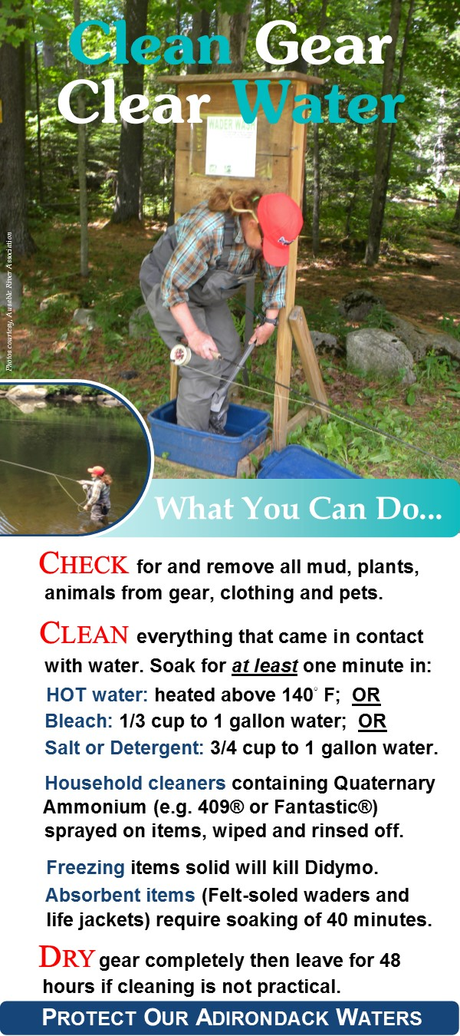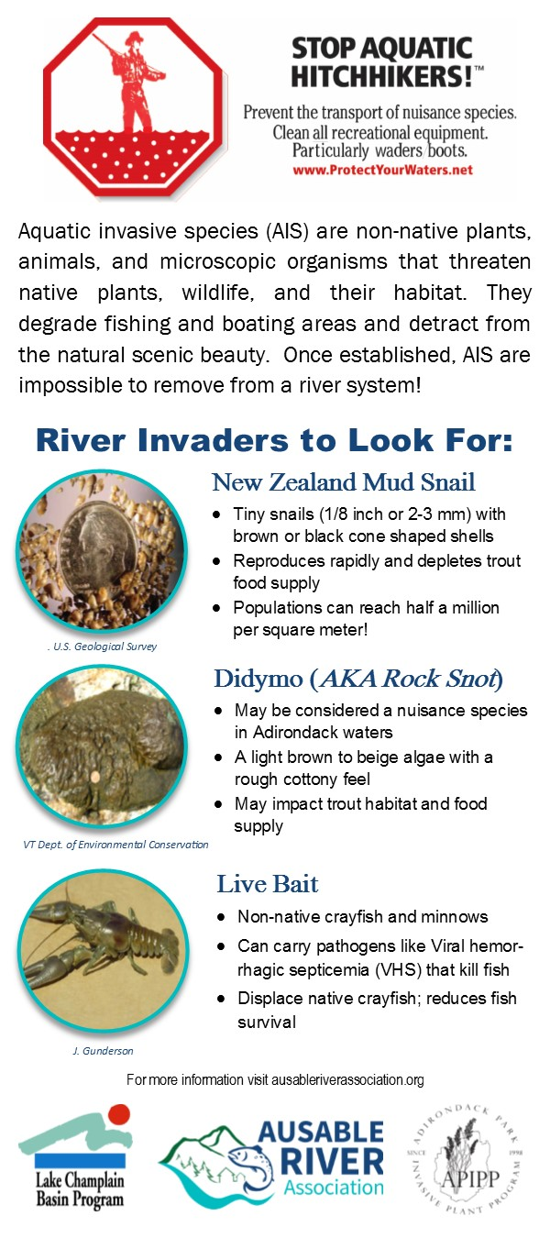

Kilroy, Cathy, Amy Lagerstedt, Andrew Davey, & Karen Robinson. 2006. Studies on the survivability of the invasive diatom *Didymosphenia geminata* under a range of environmental and chemical conditions.

*NIWA Client Report: CHC2006-116.*National Institute of Water and Atmospheric Research Ltd, Christchurch, New Zealand. Revised May 2007.

Spaulding, Sarah & Leah Elwell. 2007. Increase in nuisance blooms and geographic expansion of the freshwater diatom *Didymosphenia geminata*: Recommendations for response.

Appendix II: Wader wash station location map and “Clean, Check, Dry” brochure

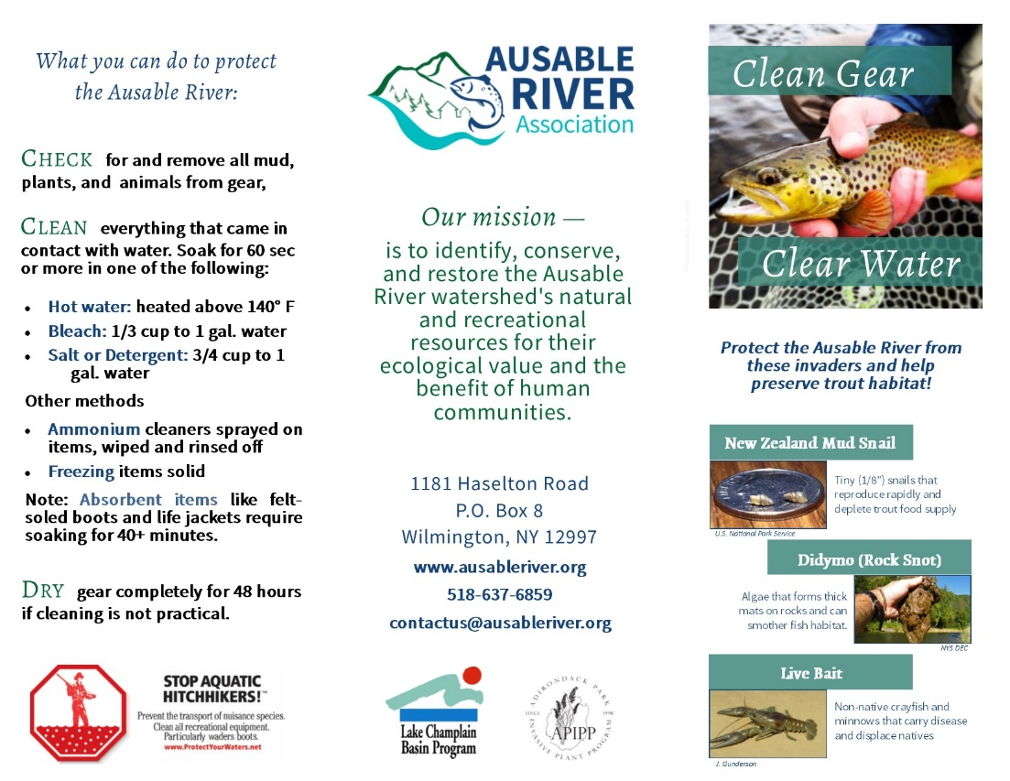

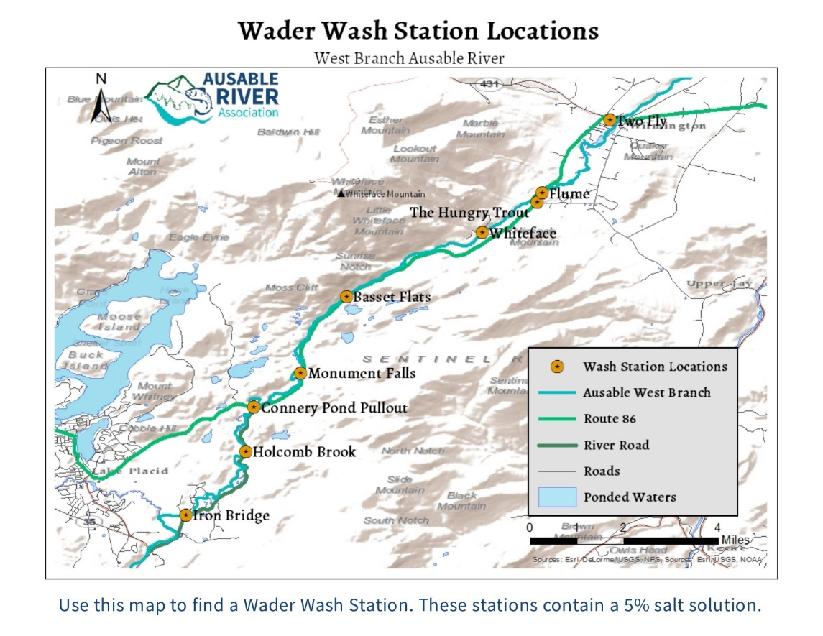

Appendix III: 2015 river user survey data sheet

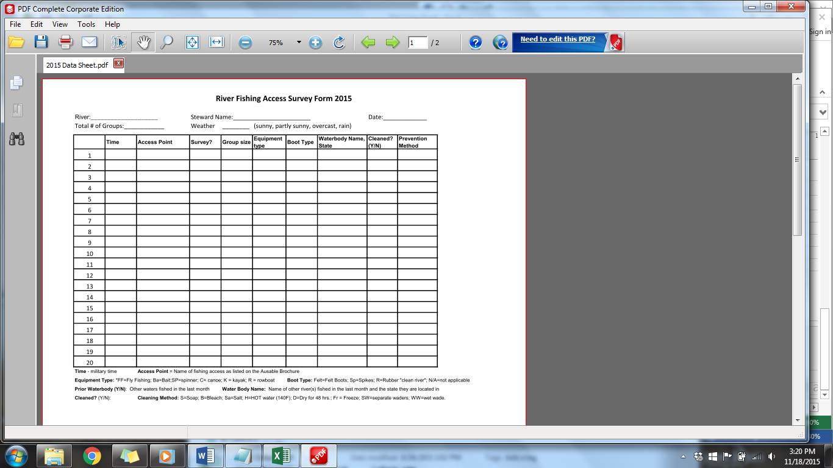

Appendix IV: Wader wash station informational sign

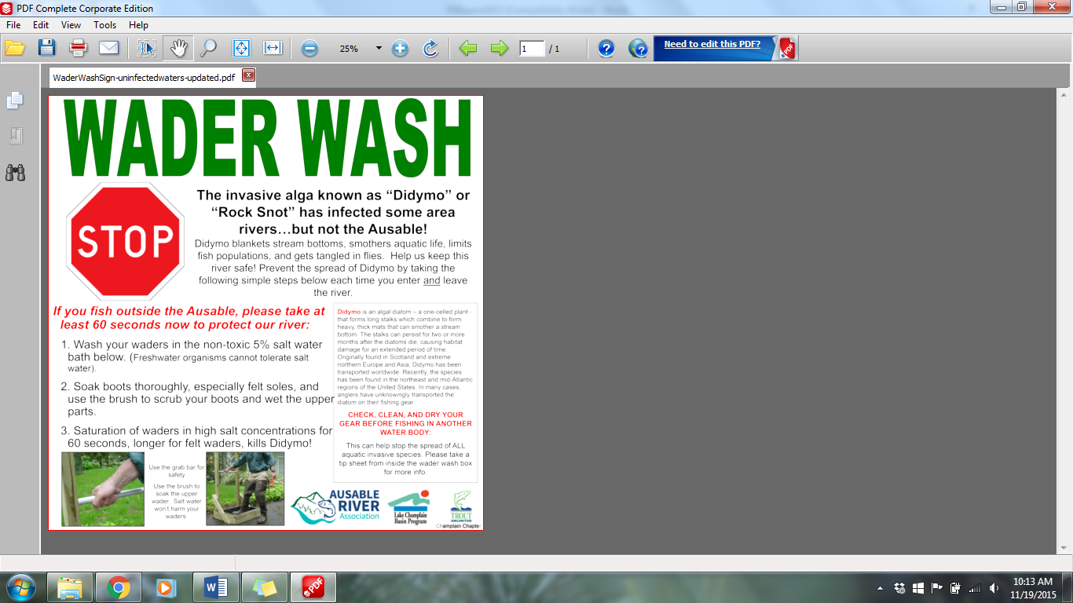

Appendix V: Weed information management system data sheet

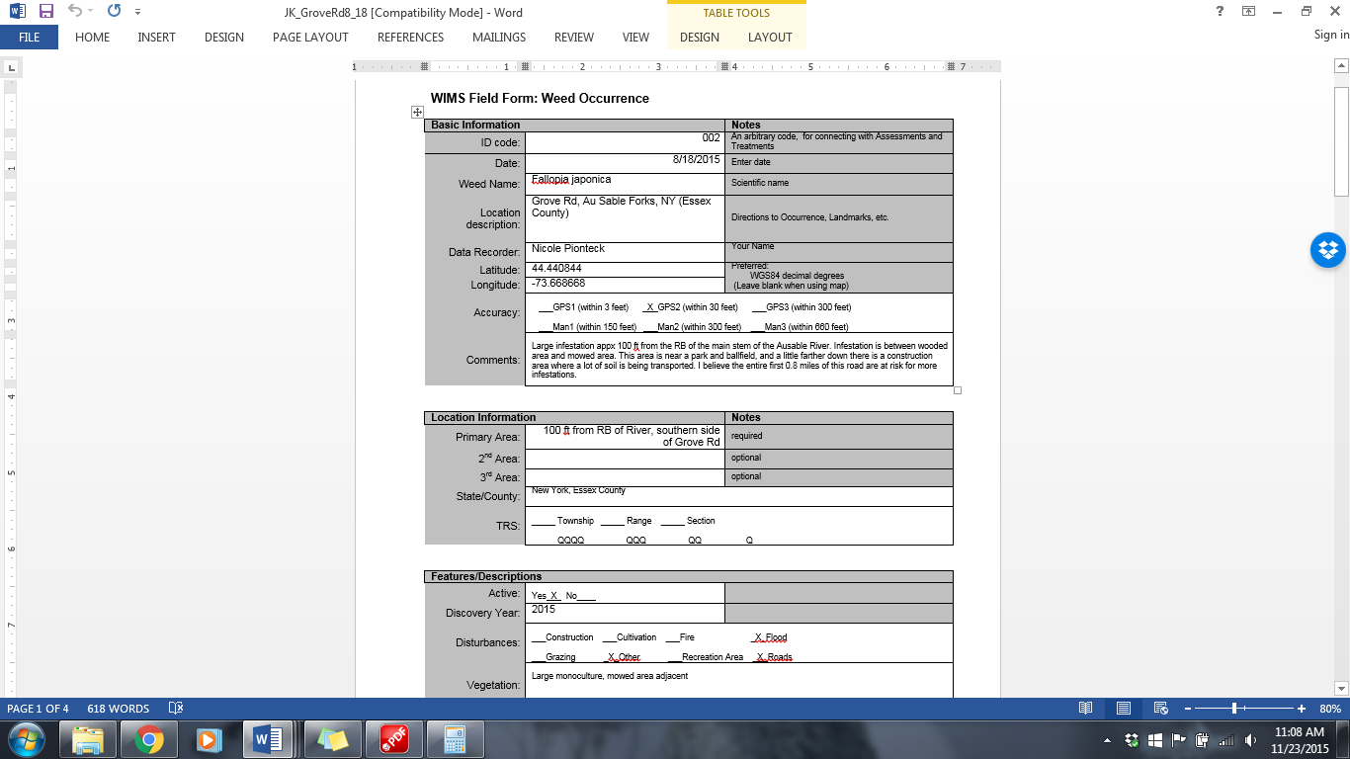

Appendix VI: Selection of 2015 survey data in Excel

