Draft Meeting Summary
Members Present: Walt Lender (Chair), James C. Dawson, Laura Klaiber, Steve Kramer, Tom Metz, Colin Powers, Vic Putman, Ricky Laurin, Charlotte Staats
Members absent: Jackie Bowen, Jane Gregware, Fred Woodward
Public Guests: Helen Polanco (NYSDEC), Michele Fafette (EPA R2), Aude Lochet, Chris Maron, Nicole Pionteck
Presenters: Lauren Jenness Kneen (LCBP), Carrianne Pershyn (AsRA)
LCBP Staff: Katie Darr, Erin Vennie-Vollrath (NYSDEC)
Meeting summary prepared by Katie Darr, Lake Champlain Basin Program

1:00 – 1:15 pm
- Welcome and Introductions (5 min) – Walt Lender, Chair
- Public Comments (5 min)
No public comments were made.
- ACTION ITEM: Review and vote on Draft March 4th meeting summary (5 min) – Walt Lender, Chair
Motion to approve by: Vic Putman
Seconded by: Jim Dawson
Abstentions: None
Discussion: None
Vote: All in favor, motion carried
1:15 – 1:50 pm
- Stream Wise – Lauren Jenness Kneen (LCBP)
Lauren provided an overview of Stream Wise which seeks to educate and engage streamside property owners to enhance and protect vegetated stream buffers on their land to protect and restore healthy waterways across the Lake Champlain Basin. Her presentation is available with the meeting materials (here).
Discussion
- Walt asked for clarification about the number of assessments that will be completed in New York this year. Lauren shared that the contracts are issued on an annual basis, this year Paul Smiths College and the Ausable River Association have proposed to complete 5-7 and 7-8 assessments, respectively. In total over 100 will be completed including Vermont and Quebec groups.
- Jim asked about property eligibility. Lauren noted that eligibility for the Stream Wise award is based on the criteria. Last year, 76 assessments were conducted, but only 42 awards were issued. Property owners are eligible for an assessment whether they think they would pass or know they need technical assistance.
- Walt asked if there is a cost to property owners to have the assessment. Lauren confirmed there is no cost to property owners and shared that some organizations have written into their contracts to provide free trees, rebates, etc. to help improve the property buffers.
- Colin asked if Lauren anticipates the property owners that did not receive certification last year to make improvements and come back in for re-assessment and certification. Lauren shared that at least two properties had grass all the way down to the stream and knew more tree plantings and buffers would be needed.
- Tom asked how the program is advertised. Lauren noted there is a dedicated Stream Wise website , Facebook, and Instagram in addition to printed outreach materials that are available to anyone who wants to promote Stream Wise. Having consistent branding and messaging is an important component of the program.
- Walt asked how the NYCAC might help spread the word. Lauren shared the main focus is getting landowners to sign up. Last year, PSC and AsRA did not have much trouble getting landowners to participate. Vermont Lake Wise has a “gold status” for lakes that have 15% or more of the surrounding properties with the lake wise award. Stream Wise is considering a similar program on a town level which may help spread the word and garner more interest in the program.
- Chris asked if the program applies to land trusts and conservation groups particularly for conservation easement properties. Lauren clarified that land trusts and conservation groups are eligible. Stream Wise was created to target residential property owners as that was an identified gap. Land trust properties can be assessed, but residential areas are prioritized.

1:50 pm – 2:30 pm
- Ausable River Association (AsRA) Updates – Carrianne Pershyn (AsRA)
Carrianne provided updates related to AsRA’s Stream Wise participation and other activities relevant to NYCAC interests including biodiverse habitats research, clean water research, stewardship and community engagement, and healthy streams projects. Her presentation is available with the meeting materials (here).
Discussion:
- The committee was appreciative of the presentation and impressed by the tremendous amount of work AsRA is doing.
- Michele noted there is no such thing as a "naturalized" plant. It is non-native. Plants are either native or not. The term "naturalized" is something commercially made up to have people feel better about non-native plants and shouldn't encouraged. Only native plants should be encouraged. Carrianne noted AsRA continues to prioritize management of these non-native species which are sometimes overlooked since they have been on the landscape so long. They often do not get the same attention as newer invasive species.
- Erin asked about the metabarcoding for species and whether AsRA has worked with USFWS’ efforts to detect round goby or other invasive species. Carrianne shared that the database they use detects for ~250 fish species. AsRA utilizes the same sampling protocol as USFWS, though AsRA is not working in the lake directly.
  - Walt asked if one test can test for multiple types of fish. Carrianne confirmed that with eDNA metabarcoding, one sample can test for multiple types of fish. PCR on the other hand can only detect ~3 species. Metabarcoding is more expensive but provides more data.
- Walt asked about the target level for salt. Carrianne shared that the target level is less than 40 mg/L by 2025.
- Walt asked if AsRA is working with Trout Unlimited on culvert replacement. Carrianne noted that AsRA and Trout Unlimited share technical expertise in both directions on these projects.

2:30 – 2:40 pm
- World Water Day Debrief – Katie Darr (LCBP), Jim Dawson (NYCAC)
Jim and Katie tabled on behalf of the NYCAC at the March World Water Day event at the Champlain Centre Mall. Over 60 people participated in filling out the “Love the Lake” poster with things they love about the lake, how they show their love for the lake, or a place they love in the basin (word cloud of common answers below). 5 people signed up to receive the public meeting notice emails. Laura participated on behalf of Miner Institute and noted it was valuable to interact with a wider demographic and meet people where they are. Colin and Vic participated on behalf of BRASS and seconded Laura’s comments.

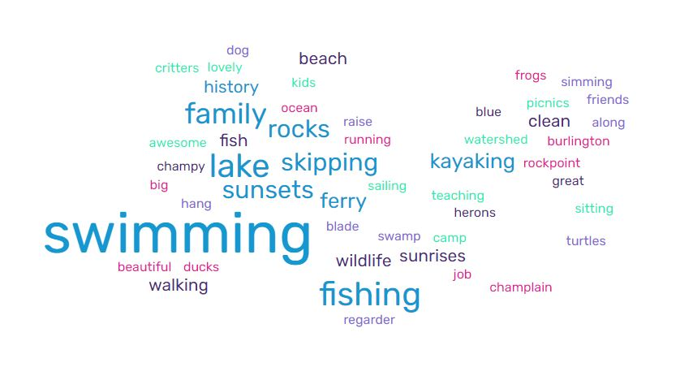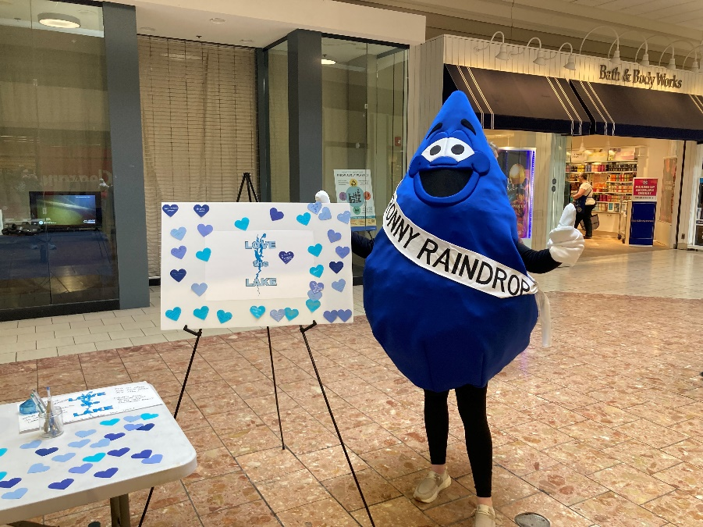

2:40 – 2:50 pm
- Updates – Walt Lender, Chair
LCBP
- On March 14th, Congresswoman Stefanik sent a letter to LCBP and the Great Lakes Fishery Commission urging the establishment of offices near LC on the NY side of the lake with a focus on public outreach and educational efforts. LCBP, GLFC, and Congresswoman Stefanik’s staff have been meeting to brainstorm what this might look like. Currently focusing in on the Plattsburgh area and spaces that might receive a lot of foot traffic, as the primary goal is for this to serve as an outreach space/resource room to engage the NY public with Lake Champlain with secondary goals for desk and conference space for staff. This is something that would be great to have NYCAC feedback on.
- The FY24 budget was approved at the April Steering Committee meeting with three new staff positions proposed and over $14M in grant program funding
- State of the Lake release will happen on Wednesday, June 5th at the LCBP office in Grand Isle, VT.

BRASS
- BRASS, Trout Unlimited, Essex County Soil and Water Conservation District, the Arbor Day Foundation, and Verizon are holding a tree planting event April 26 & 27.
- The Salmon Symposium will be held on Friday, May 10th at the Noblewood Park Pavilion in Willsboro from 11AM to 2 PM. The event is open to the public interested in the progress, planning, and future of salmon restoration in the Lake Champlain Watershed. Speakers will include Laurie Earley, Chris Smith, David Minkoff from US Fish & Wildlife Service and Nicole Balk from New York Department of Environmental Conservation. The Town of Willsboro will provide refreshments.
- BRASS will hold its annual meeting on May 10th from 5-7:30pm at the BRASS office located at 3743 Main Street in Willsboro. Light refreshments will be available.

NYSDEC
- NYSDEC finalized the TMDL implementation plan.
- Commissioner Seggos has stepped down, Sean Mahar is the interim commissioner.

Other Updates

- Tom reported on the Earth Day event at Trinity Park. One of the tables there was the PR team from Champlain Hudson Power Express project. had a coaster that is 5 inches in diameter, representing the size and layers of the cable they will install at the bottom of the lake. They will trench below 150 feet, before that depth the cable will be held between two concrete mats for protection. The cable is the same or similar to one being used extensively in Denmark. The life span is fairly good, estimated more than 50 years because it’s deep enough that anchors won’t be dragged across it.
- Laura shared the Clinton County Water Quality Committee met last week and talked about work they’ve been doing on the new wastewater treatment plant building. In the future, they are planning to do more community outreach and have some sort of meeting space.

2:50 – 3:00 pm
- Meeting Wrap Up – Walt Lender, Chair & Katie Darr (LCBP)

- Katie has reached out to the Champlain Hudson Power Express team requesting a public presentation about the power line installation work that will be underway this summer and the Hudson River Foundation about the accompanying Champlain Hudson Environmental Trust. This informational meeting is tentatively scheduled for May 15th from 5-7pm via Zoom (pending confirmation from the CHPE team).
- The next NYCAC meeting is scheduled for May 20th from 1-2:30 pm via Zoom. This meeting will feature a presentation about the rights of nature by Blake Lavia and Tzinztun Aguilar-Izzo from Talking Rivers and a discussion about the proposed NY resource room space.
- Katie and Walt will work together on scheduling an in-person June meeting at the Silver Bay YMCA featuring an update about the Lake George Septic Inspection program.

